**Egyptian E-Learning University**

Faculty of Computers & Information Technology

**Find It**

|  |  |
| --- | --- |
| Name: Ahmed Saber Hafez | ID: 21-00388 |
| Name: Ahmed Esmat | ID: 21-00392 |
| Name: Ahmed Sayed | ID: 21-00383 |
| Name: Ahmed Mohamed | ID: 21-00131 |
| Name: Mariam Ezat Mahrous | ID: 21-00978 |
| Name: Mirna Micheal Sadek | ID: 21-01123 |
| Name: Caroline Emel | ID: 21-00589 |

Supervised by

Dr. Muhammed Attia

Assistant

Eng. Ahmed Hany

[Asuit]-2025

Abstract

In a world of growing and accelerated, we often lose valuable things to carry out material or moral value. Hence, the idea of our website came "retrieved", which is the ideal solution to help people find their lost property easily and quickly. The site works as a link between those who find missions and those who are looking for, via an easy-to-use system and fully insured. Allows users to register their lost or find their impaired configurations, with accurate details and images facilitate the conformity process. Our goal is to build a cooperative society that enhances safety and trust, and makes the recovery of missing is simple and available to everyone. Whether you are looking for something precious lost or wanted to contribute to another person's happiness, "retrieved" is the place that brings us together to make the difference together

Acknowledgments

It has been a great opportunity to gain lots of experience In **AI Enhanced Lost Found System**, For that we would like to express our deepest gratitude to all who have made this project possible. First and foremost, we would like to thank Allah for providing us with the knowledge, skills, and opportunity to complete this project. We would also like to thank our project supervisor,

**Dr. Muhammed Attia,** for his tremendous support and guidance. Without his encouragement and guidance, this project would not have materialized. He has been a great mentor and has helped us to learn a great deal about search engines and recommendation systems. We are also grateful to our **Eng. Ahmed Hani,** for helping them and support. He has been a valuable resource and has helped us to improve our project in many ways. We are very proud of the work that we have done on this project, and we hope that it will be useful to others

Contents

Abstract 2

Acknowledgments 3

Introduction 5

Literature Review / Related Work 7

Proposed system 9

Implementation 11

Testing & Evaluation 13

Results & Discussion 15

Conclusion & Future Work 17

References 19

Appendices (Optional) 21

Chapter 1

Introduction

* 1. Introduction
  2. Background and motivation for the project.
  3. Importance of the problem being addressed.
  4. Problem Statement

- Clear definition of the problem your project addresses.

- Justification for why this problem is worth solving.

* 1. Objectives

- Main Objective: The primary goal of the project.

- Specific Objectives: Breakdown of tasks required to achieve the main goal.

* 1. Brief overview of the proposed solution.

**1.1 Introduction:**

The first chapter provides an overview of the project, explains its purpose, scope, objectives and methodologies used to develop the system, and presents the tools, techniques and machine learning algorithms used to build a platform that in turn, or among the services of this platform, brings together several people of two different types: the first, the person who lost something and wants to find it, in conjunction with the second person who found something missing and wants to deliver it to those who lost it. The site brings them together and from among the inventory in the databases, each person identifies the appropriate thing that he lost and that someone found by using artificial intelligence, especially the properties of recognizing things and the system of matching them with each other to verify the correct person who owns those lost things by the date of loss and some of the features of his lost things, and finally they will communicate with each other and deliver the lost things. So the site helped save time and effort in finding the owners of the lost things, and we developed artificial intelligence tools and used them here in a simplified way.

Overall, this project represents a significant step towards harnessing technology to solve real-world problems, demonstrating the power of AI to simplify everyday challenges. By providing a structured, efficient, and automated approach to handling lost and found items, the platform aims to change the way individuals and organizations manage and recover their lost property.

**1.2 Background and motivation for the project:**

The main objective of the proposed AI-Enhanced Lost and Found System is to assist users in efficiently identifying, and recovering lost items by utilizing advanced AI algorithms.

Traditional methods for lost and found rely heavily on manual intervention, making the process time-consuming and error-prone. To address these challenges, the system incorporates intelligent techniques such as recommendation systems and image recognition

**1.3 Importance of the problem being addressed:**

The problem of lost and found items is a significant issue that impacts individuals and organizations alike. People often misplace personal belongings in public spaces, workplaces, or transit systems, leading to inconvenience, financial loss, and emotional distress. Traditional methods of handling such situations, like physical notice boards or manual record-keeping, are inefficient and prone to errors. AI Enhanced lost and found System addresses this problem by offering a centralized, accessible platform where users can report lost or found items. It streamlines the process, increases the likelihood of recovering items, and saves time and effort for all parties involved.

**1.4 Problem Statement:**

Every day, people lose valuable items, such as, phones, ID Cards and personal documents, creating stress and Inconvenience.

-Current methods, such as social media posts or community Boards, are often unorganized, time- consuming, and Ineffective.

- No dedicated, user-friendly Platform exists to connect people who lose items with those who find them?

-Inefficiency in Communication: Difficulty in verifying Ownership or finding direct ways to contact the rightful owner.

-Low Trust and Security: Concerns about fraud, privacy Breaches, or misuse of personal information when claiming lost items

- Lack of an accurate classification system: Difficulty in classifying lost and found items in a way that makes them easy to search for and retrieve quickly.

- It takes long days to find the missing item, and that's why we created the platform to speed up the search.

**1.5 Objectives:**

* Intelligent Matching System: Develop an AI-driven recommendation system to accurately match lost and found items based on detailed descriptions and attributes.
* Ensuring users receive the most accurate and prioritized matches based on the provided.
* to locate lost or found items efficiently using specific filters such as item type, date, location, And keywords.
* Notification System: Introduce a notification feature that alerts users when new reports.
* Match their lost or found item descriptions, increasing the likelihood of successful recovery.
* Enhancement of safety and credibility: Providing reliable verification mechanisms to prevent false or fraud reports such as the request for registration of the national number of users to prevent fraud.

**1.6 Brief overview of the proposed solution:**

The proposed solution is AI Enhanced Lost and Found System designed to connect individuals who have lost personal belongings with those who have found them. The website will serve as a centralized, user-friendly platform where users can create detailed listings of lost or found items, including descriptions, photos, and location details.

Key features of the proposed solution include:

1. Search and Filter Functionality

2. Secure User Accounts

3. Real-Time Notifications

Chapter 2

Literature Review / Related Work

2.1 Summary of existing research and technologies related to your project.

2.2 Gaps in current solutions that your project aims to fill.

2.3 Summary

**2.1 Summary of existing research and technologies related to your project:**

1. Traditional Lost-and-Found System

Examples: Notice boards, customer service desks.

2. Online Classified Websites

Examples: Craigslist, OLX, Gumtree.

3. Social Media Platforms

Examples: Facebook, Twitter, Reddit.

4. Dedicated Lost-and-Found Platforms

TROOV.com

Lostings.com

FindMyLost.com

5. Smartphone Applications

PAAYA

Lost & Found App

**2.2 Gaps in current solutions that your project aims to fill:**

1. Traditional Lost-and-Found Systems:

Limitations:

Lack of scalability beyond local areas.

Inefficient manual processes.

Time-consuming for both users and administrators.

2. Online Classified Websites:

Weaknesses:

No specific categorization for lost-and-found items.

No secure communication features or verification systems to ensure authenticity.

3. Social Media Platforms:

Weaknesses:

Lack of structured search mechanisms.

Posts easily get lost over time.

No verification systems.

4. Dedicated Lost-and-Found Platforms:

Common Weaknesses Across Platforms:

Absence of AI chatbots for real-time assistance.

Lack of multimedia integration (e.g., videos or news) to engage users.

Limited use of recommendation systems to suggest potential matches.

5. Smartphone Applications:

Weaknesses Across Apps:

Limited advanced search and filtering options.

Absence of multimedia features like news or updates.

Missing AI-powered chatbots and recommendation systems.

Our Project Fills These Gaps:

1. Advanced Search & Filtering:

Implement robust filters for category, keywords, and time of loss.

2. AI-Driven Features:

Use AI for:

Chatbots to assist with real-time queries.

Recommendation engines to suggest potential matches.

3. Secure and Verified Communication:

Include user verification to ensure trust between parties.

**2.3 Summary:**

Various existing systems and technologies address the issue of lost and found items, ranging from traditional methods like notice boards and customer service desks to online classified websites such as Craigslist and OLX, social media platforms, dedicated lost-and-found websites, and smartphone applications. Despite their availability, many of these solutions face challenges including lack of user verification, insufficient structured and advanced search capabilities, limited multimedia integration, and absence of real-time interactive features.

Dedicated platforms and mobile apps, in particular, often lack AI-powered functionalities such as chatbots for instant assistance and recommendation engines to suggest potential matches, which reduces the overall efficiency of the lost-and-found process. Additionally, secure communication and user verification mechanisms are frequently missing, affecting trust between users.

This project aims to fill these gaps by developing an integrated system that offers advanced search and filtering options, AI-driven chatbots and recommendation systems, and secure user verification. These enhancements are expected to improve user experience and significantly increase the chances of recovering lost items quickly and safely.

Chapter 3

Proposed system

* 1. Approach used to solve the problem
  2. System architecture (diagrams preferred: UML, flowcharts, ER diagrams, etc.).
  3. Algorithms or frameworks used.

**3.1 Approach used to solve the problem:**

Based on the limitations observed in existing lost-and-found systems, the proposed system incorporates innovative features to enhance usability and functionality: Combining Recommendation System with Search Engine: Unlike existing platforms, which either provide static search functionalities or basic item categorization, this proposed system uniquely combines a recommendation system with a dynamic search engine. It assists users in both actively searching for lost items and receiving tailored recommendations based on historical data and user preferences.

Hybrid Recommendation Techniques: The system integrates hybrid filtering techniques: Content- Based Filtering (CBF): Uses criteria related to item specific attributes (e.g., type, location, date lost, description) to suggest potential matches. Collaborative Filtering (CF): Leverages historical user interactions, such as similar reports of lost/found items, to refine recommendations. This hybrid approach ensures greater accuracy by incorporating multiple criteria, surpassing the limitations of previous systems.

Targeted for Specific Users: The proposed system aims to provide personalized assistance for individuals reporting lost or found items. It ensures that users can efficiently locate items or report discoveries with minimal complexity.

Data Collection and Dataset Creation:

To create a robust dataset for the system, information was collected from:

Existing Lost-and-Found Databases: Data from platforms like MissingX and local community boards were analyzed and adapted.

Public Sources: Crowdsourced information from social media, community websites, and city-based lost-and-found services was utilized to enhance dataset comprehensiveness.

User-Submitted Reports: Users contribute directly by reporting lost or found items, enriching the dataset over time.

User-Friendly Interface: The system is designed with simplicity in mind, ensuring that users of varying technical abilities can interact with it seamlessly. Intuitive navigation, visual aids, and guided steps simplify both the reporting and searching processes.

Integrated Search and Match Capabilities: The search engine allows users to locate items based on customizable criteria, such as time, location, and item description. Meanwhile,

The recommendation system proactively suggests potential matches for lost or found items, improving efficiency and reducing search times.

**3.2 System architecture (diagrams preferred: UML, flowcharts, ER diagrams, etc.):**

**-Context Diagram**

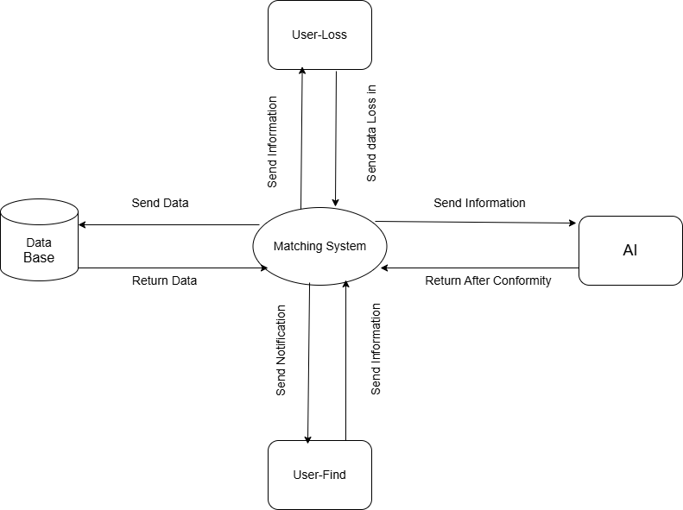

**-Use case Diagram**

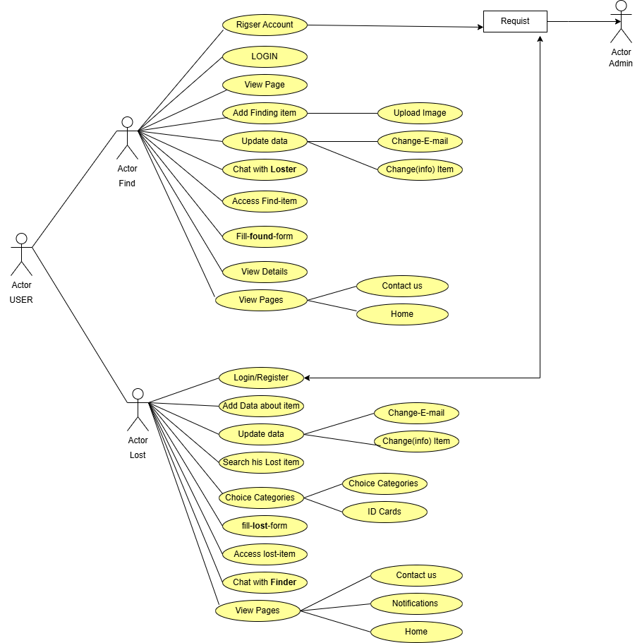

**-Use Case Table**

**(1)**

|  |  |
| --- | --- |
| UseCase Name | Sign Up |
| Actors | Admin, Lose-User , Find-User |
| Include |  |
| Precondition | No requirement for first-time registration |
| Data Input | First Name , Last Name , Email , address , Create Password , Confirm Password , National ID ,Phone number |
| Description | The user creates a personal account by adding the first name, last name, address, card number, and finally the phone number, then the verification process occurs through the validity of the e-mail or not, and if the email is not correct, a message appears to you "Error in registration?!" and then the official reviews the request ... |
| Comments | The user can create only one account with his national number, but the email allows it to be modified |

**(2)**

|  |  |
| --- | --- |
| Use Case Name | Sign In |
| Actors | Admin, Lose-User , Find-User |
| Include |  |
| Precondition | Admin , Student successfully logged in |
| Data Input | Only Email and Password or / NID Number |
| Description | If the login succeeds, your profile page is displayed, but if the registration does not work, you have an option, which is to re-register the password again, and the admin asks you for your verification code, which is sent to the e-mail |
| Comments | In an attempt to register more than once in the wrong way from someone who sends you an email message about that |

**(3)**

|  |  |
| --- | --- |
| Use Case Name | Lost-Item |
| Actor | People who lost Things |
| Precondition | Who successfully Logged in |
| Description | After successful registration, the person who has lost something searches to find the missing thing. |

**(4)**

|  |  |
| --- | --- |
| Use Case Name | Find-Item |
| Actor | People who Find Things |
| Precondition | Who successfully Logged in |
| Description | After the success of the registration, the person who found something searches and communicates with the owner of the missing thing and uploads the pictures to the site |

**(5)**

|  |  |
| --- | --- |
| Use Case Name | Search |
| Actor | People who Find or / Lost Things |
| Include | Filtering |
| Precondition | Who successfully Logged in |
| Data input | Search Text |
| Description | Both the admin and the user can use the search engine before or after registration |
| Comment | Searches show web page titles |

**(6)**

|  |  |
| --- | --- |
| Use Case Name | Verify E-mail |
| Actor | People who Find or / Lost Things |
| Include |  |
| Precondition | Who successfully Logged in |
| Data input | E-mail |
| Precondition | Sign Up |
| Description | After creating the profile, you must check when registering by sending a message to the email and clicking on activate |
| Comment |  |

**(7)**

|  |  |
| --- | --- |
| Use Case Name | Accept Account / Add |
| Actor | Admin |
| Include |  |
| Precondition | Sign In |
| Data input | E-mail |
| Description | After the user registered, the Admin adds the account and confirms it |
| Comment/Response | Student will be added to the System… |

**(8)**

|  |  |
| --- | --- |
| Use Case Name | Delete Account |
| Actor | Admin |
| Include |  |
| Precondition | Sign In |
| Data input |  |
| Description | The admin can delete any account from the system whose identity has not been verified |
| Comment/Response | Student will be removed from the system… |

**-ERD diagram**

General ERD

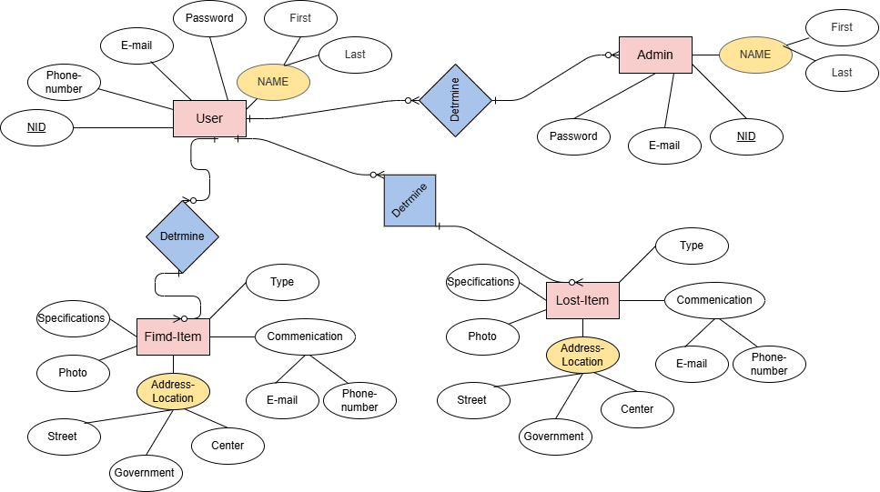

**-Phone & Card**

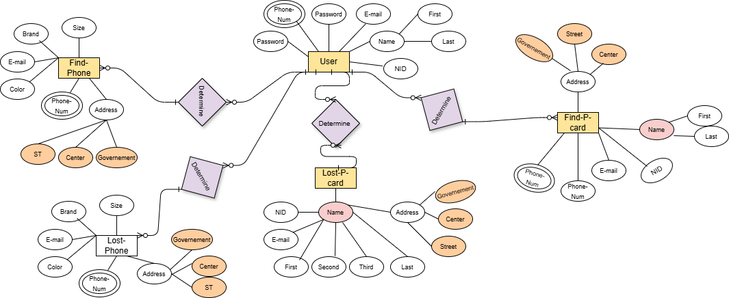

**-Class diagram**

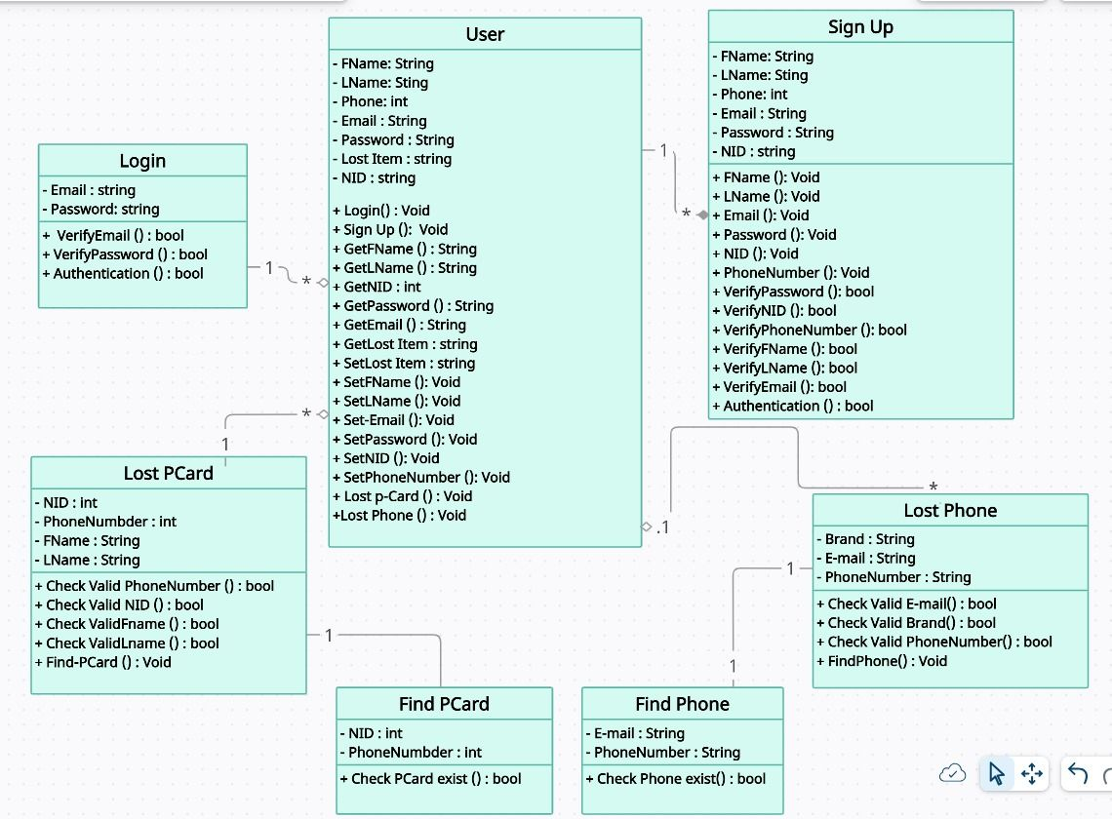

**-Sequence diagram**

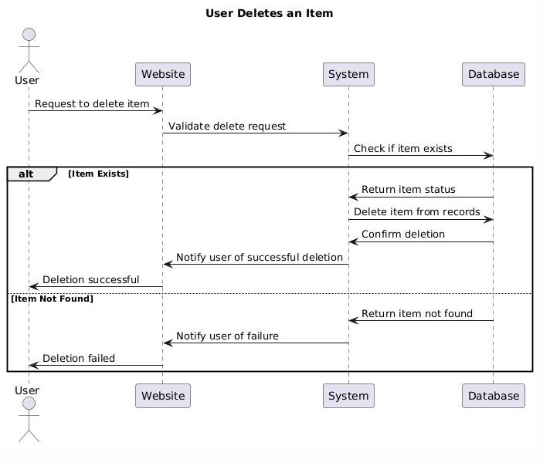

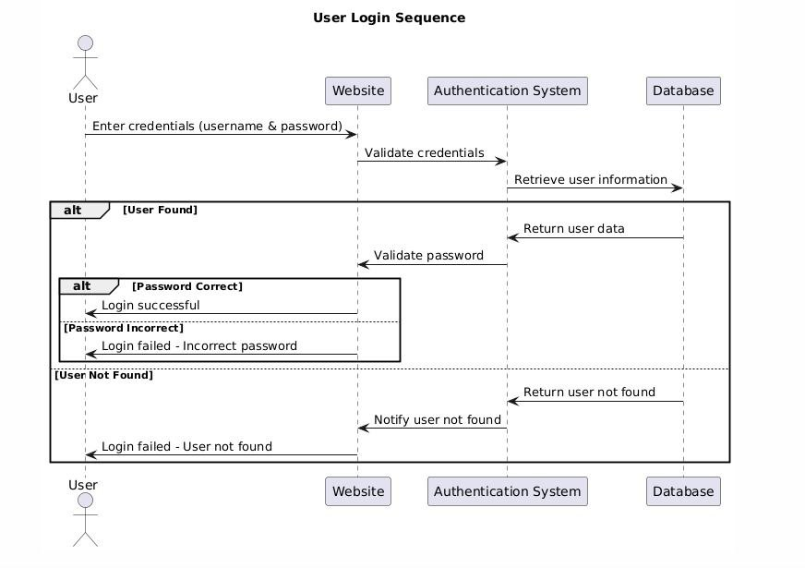

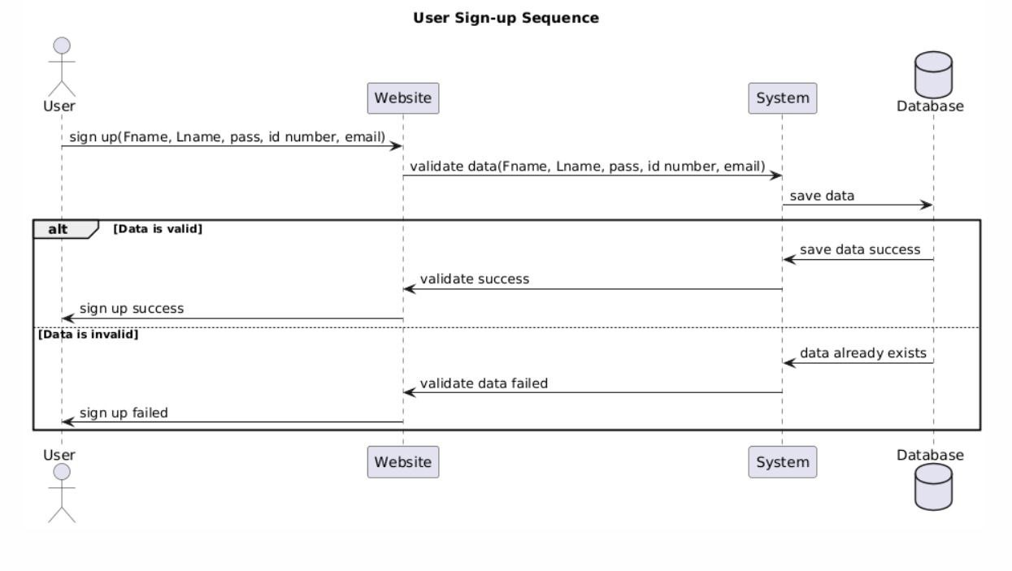

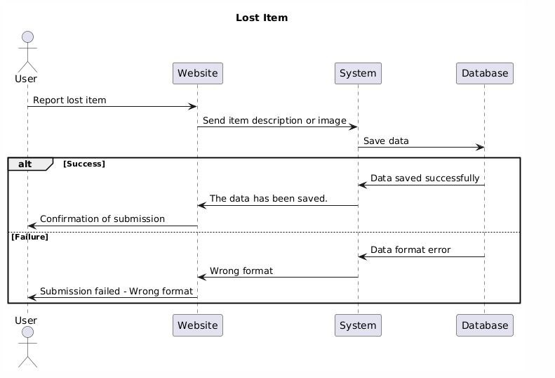

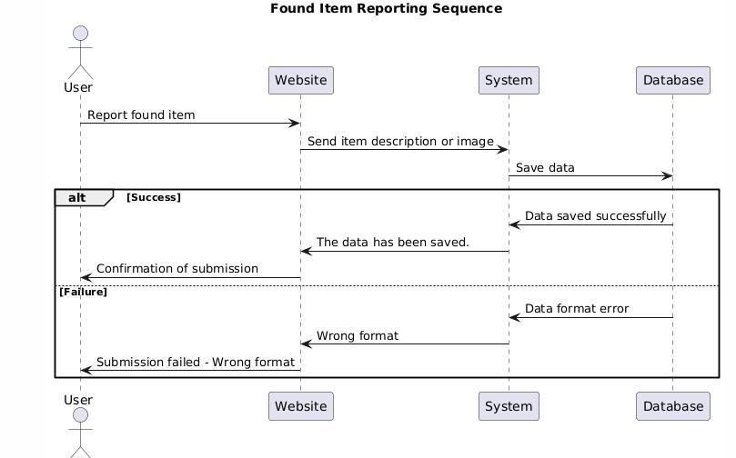

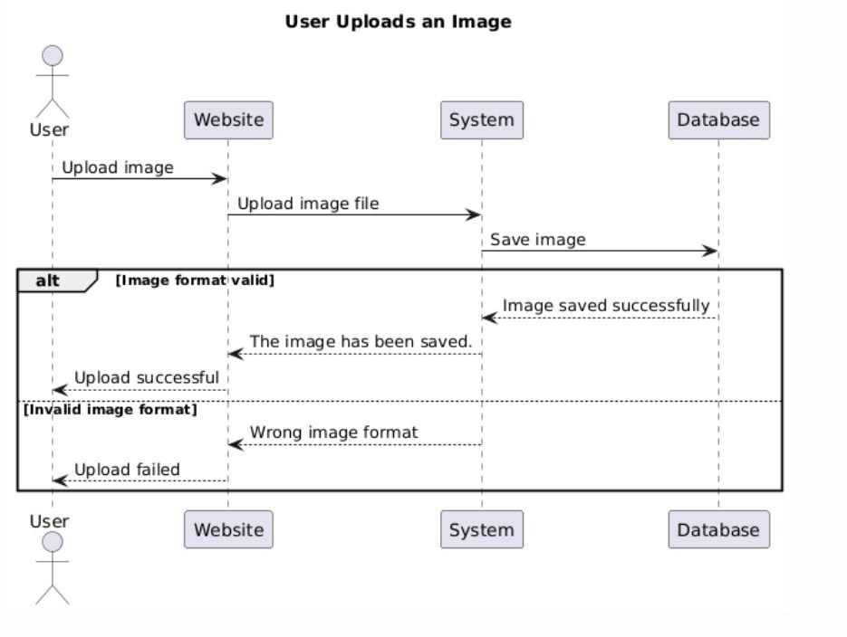

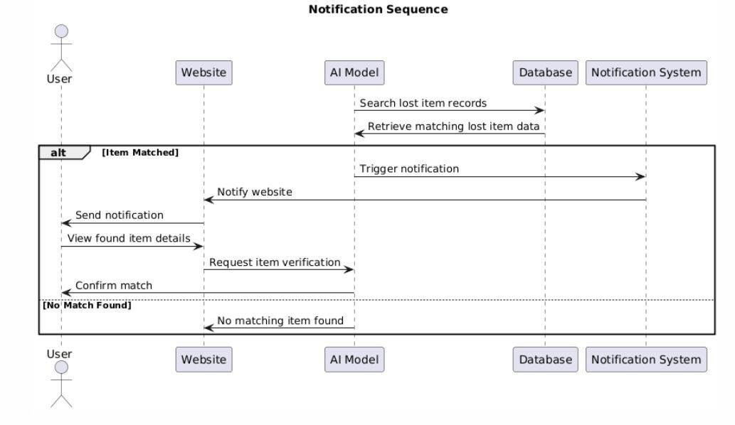

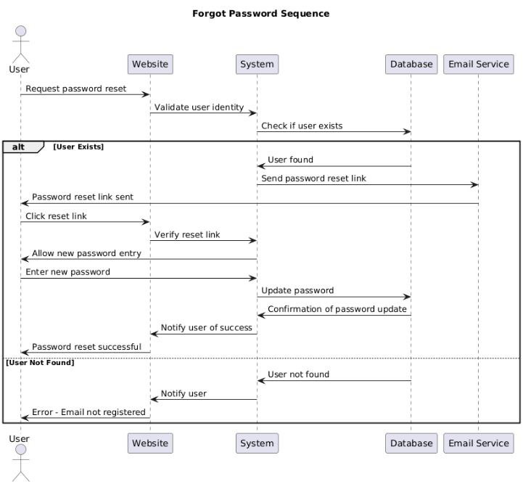

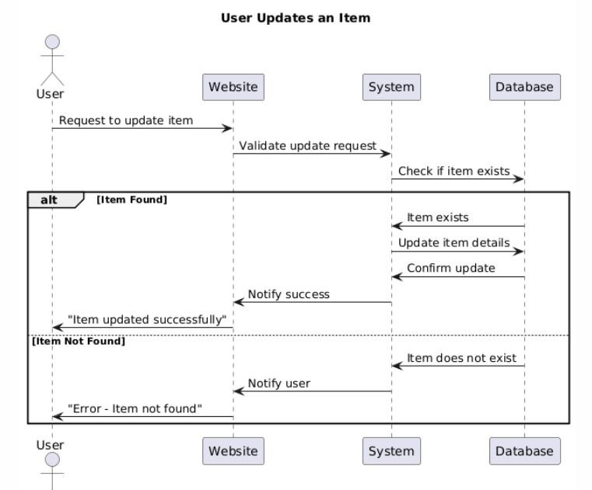

**3.3 Algorithms or frameworks used:**

AI Algorithms and Frameworks:

Sentence Transformer ("paraphrase-MiniLM-L12-v2")

Used for semantic similarity in item descriptions.

CLIP (openai/clip-vit-base-patch32)

Connects text and image embedding’s.

Used for matching item descriptions to their photos.

YOLOv8 (Face Detection)

Real-time object and face detection.

Suitable for identifying items in user-uploaded images.

DeepFace with ArcFace

Used for face verification in ID cards.

Measures facial similarity via Euclidean distance.

FAISS – for fast similarity search in image retrieval (used with CLIP).

Other Tools/Frameworks:

Express, React, SQL, .NET Core – for application logic and deployment.

Chapter 4

Implementation

4.1 Technologies, tools, and programming languages used.

4.2 Key components/modules of the system.

4.3 Challenges faced and how they were resolved.

**4.1 Technologies, tools, and programming languages used:**

UI&UX

FIGMA

Frontend

HTML&CSS

Java Script

React

APIS

Backend

Express

SQL

C

.NET core

AI

Python

Numpay

AI Libraries Mentioned:

SentenceTransformer

CLIP

* pyTorch
* DeepFace
* HuggingFace

**4.2 Key components/modules of the system:**

* **User Module:**
* User registration and login.
* Profile management.
* Reporting lost and found items (cards or phones).
* Viewing matches and receiving notifications.
* Searching using filters (category, location, etc.).
* **Admin Module:**
* Admin login and user management.
* Approving or deleting accounts.
* Viewing reports and managing posted items.
* Generating and printing reports.
* **AI Matching Module:**
* Sentence Transformer("paraphrase-MiniLM-L12-v2"): Description: Sentence Transformer is a library for creating dense sentence embeddings. paraphrase-MiniLM-L12-v2 used in tasks like paraphrase detection,
* Similarity measurement, and text clustering. It balances speed and accuracy effectively.
* Pros: 1. High Accuracy: Effectively captures semantic meanings, ideal for tasks like similarity detection
* Efficiency: Lightweight and fast for real-time applications.
* Cons: May lose some detail when processing very long or complex texts.
* CLIPModel.from_pretrained("openai/clip-vit-base-patch32"): Description: CLIPModel links text and image data. openai/clip-vit-base-patch32 uses Vision Transformer for tasks like image-text matching and zero-shot classification.
* Pros: 1. Image Understanding with CLIP: Extracts visual features for text-image alignment. Efficient Image Retrieval using FAISS: Performs fast retrieval of the top 3 visually similar images.
* Cons: Performance can drop when dealing with highly detailed or noisy images, as it may not capture all fine-grained features.
* YOLOv8 Face Detection: Description: is a modern, fast, and accurate model for detecting faces in images and videos, based on the YOLO (You Only Look Once) real-time object detection framework.
* Pros: Extremely fast in detecting faces, making it suitable for real-time applications.
* Cons: May struggle with detecting small or distant faces in images..
* DeepFace : Description: is an open-source library for face analysis that compares facial images to verify identity. It uses advanced models like

ArcFace and measures similarity with Euclidean distance, supporting applications like face matching and verification.

Pros:1. Supports advanced models like ArcFace: DeepFace allows the integration of powerful models such as ArcFace for precise face embedding extraction, improving face recognition accuracy significantly.

2. Facilitates comparison using Euclidean Distance: The library simplifies comparing extracted embeddings with Euclidean Distance, enabling accurate and fast face matching or verification.

Cons: It may struggle to accurately recognize faces in images with poor lighting or unusual angles.

* **Database Module:**

Stores user data, reports, images, and system logs.

Designed to handle structured item info (brand, color, location, etc.).

The design details are as follows:

-Home: the main page, which includes what the user needs by clicking on the top menu to navigate between the site pages, log in, communicate with the work team, etc., and also the main task, which is to use the site when finding or losing something, through the link in the middle of the page.

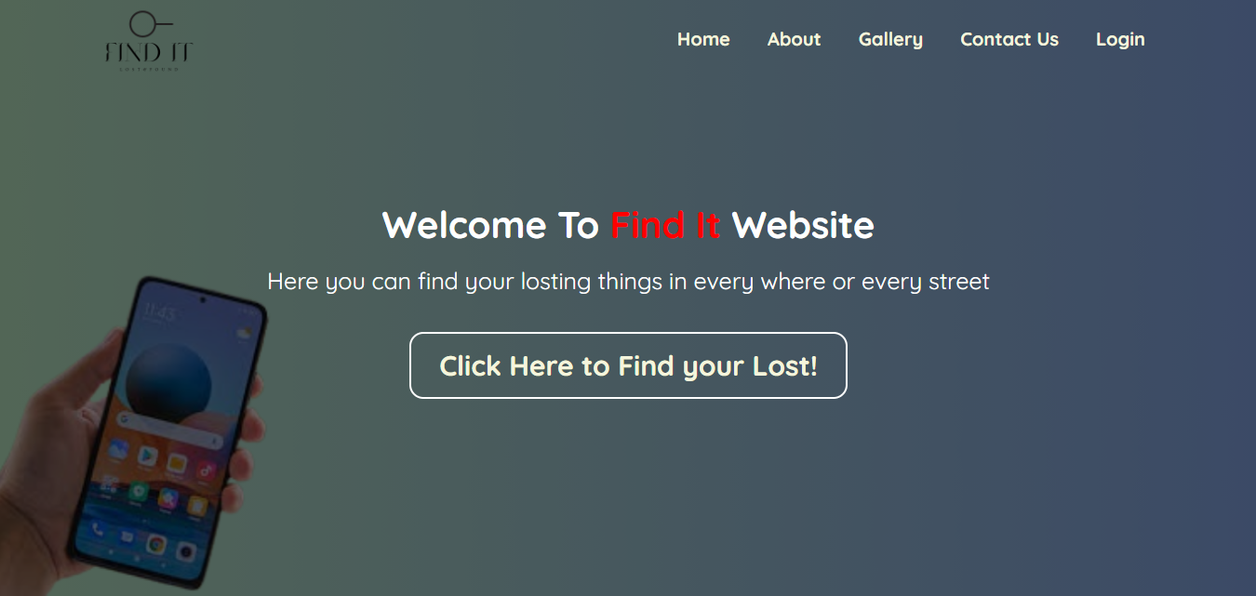

-Contact us page: Contact page with the site administrator, if there is a problem, you can contact us by adding in these fields your name with which you registered, along with the email address and subject.

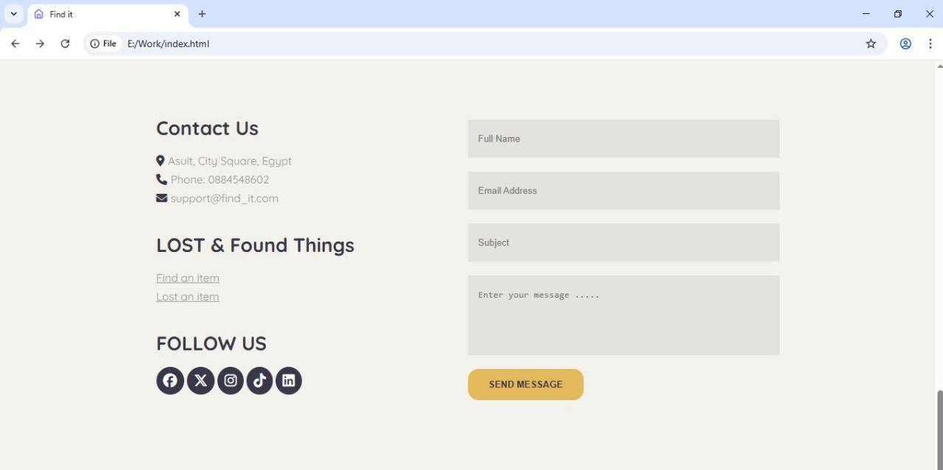

-User Sign in (Login) Login for the user by adding the email and password. If the user forgets the password, he will choose to forget password. However, if the user does not have an account before, he will create a new account with (Validation fields).

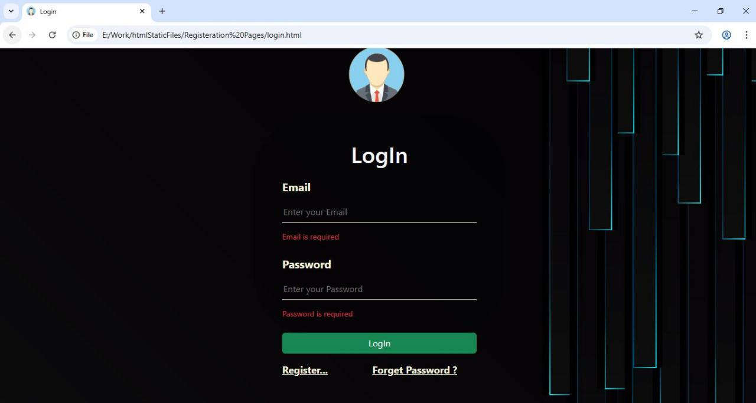

-Invalid (Login): a registration error message appears when using an invalid email address and password or when you have not registered with them before.

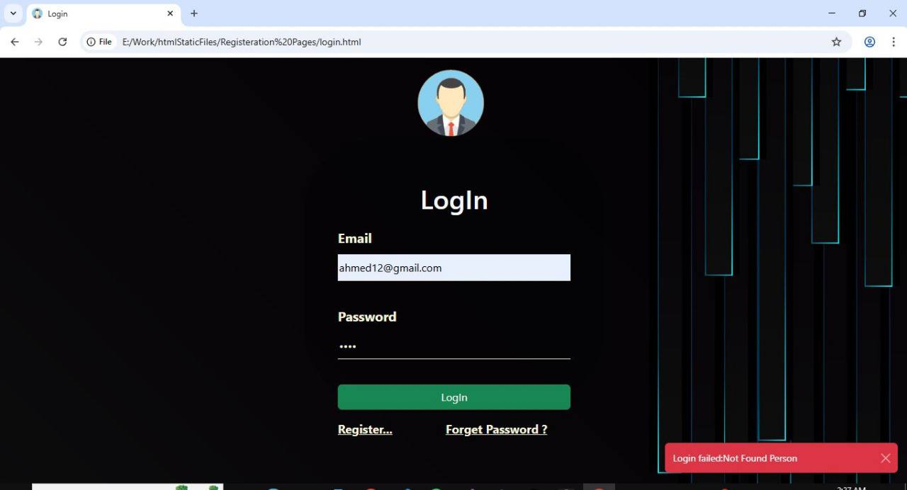

- Forget password: If the user forgets his password, he must enter the email address he previously registered with [in this field].

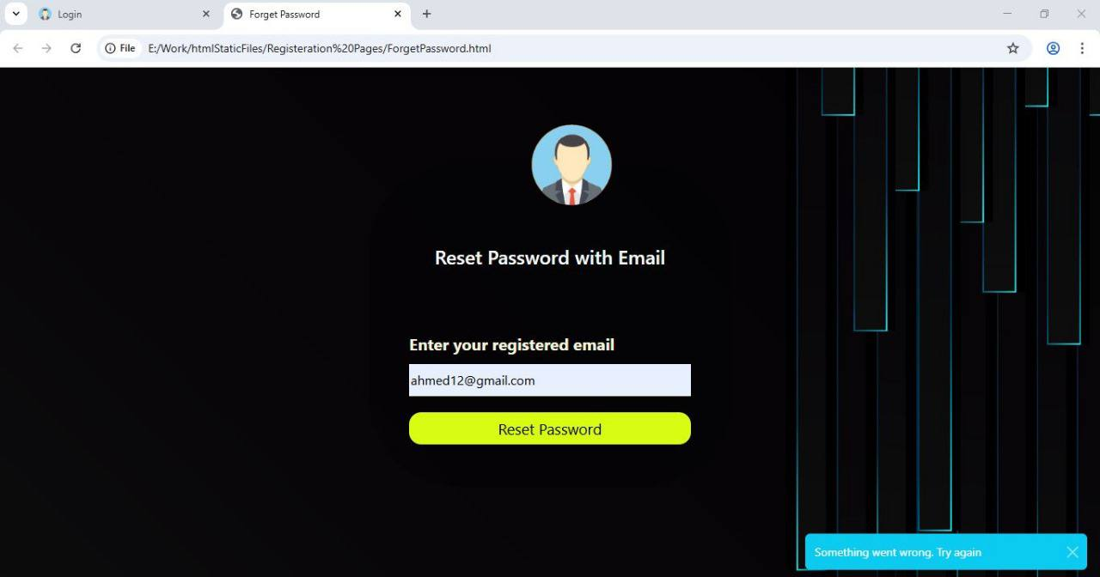

- The user responds after entering the email, entering a new password and re-entering it again with the same match until verification is completed.

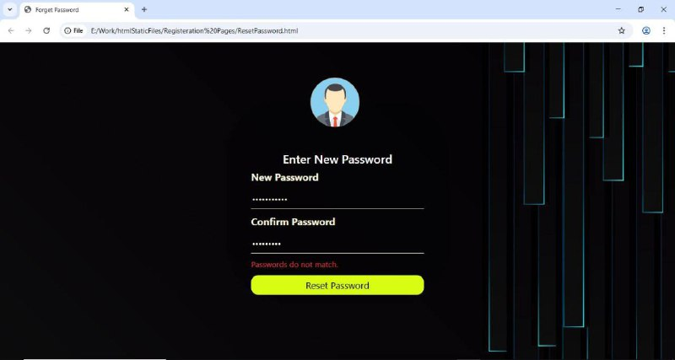

- Sign up (Register) In case of registration, the user enters in the following fields his first and last name, registration email, and his own password

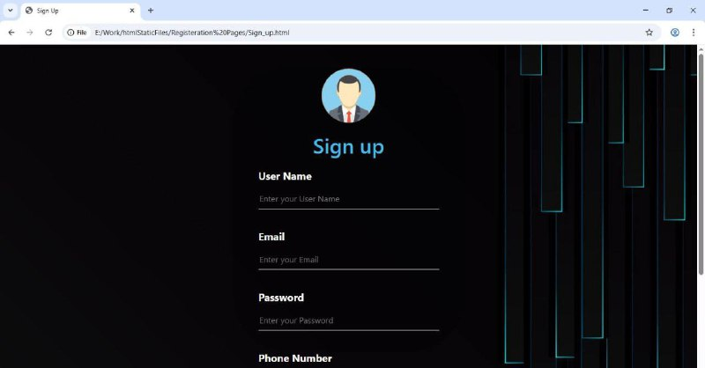

-Verify the validity of the registration: such that the national ID number does not exceed 14 digits, the phone number must be Egyptian and not exceed 11 digits, and the password must not be less than eight characters. If you enter anything other than that, verification messages will appear.

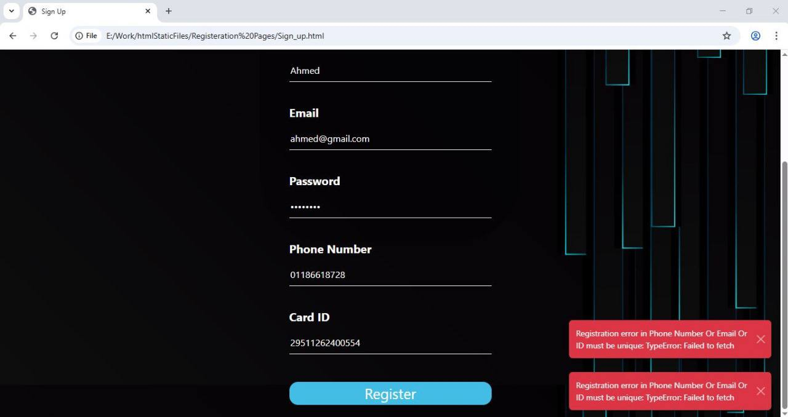

- The user can choose from: Lost or Find

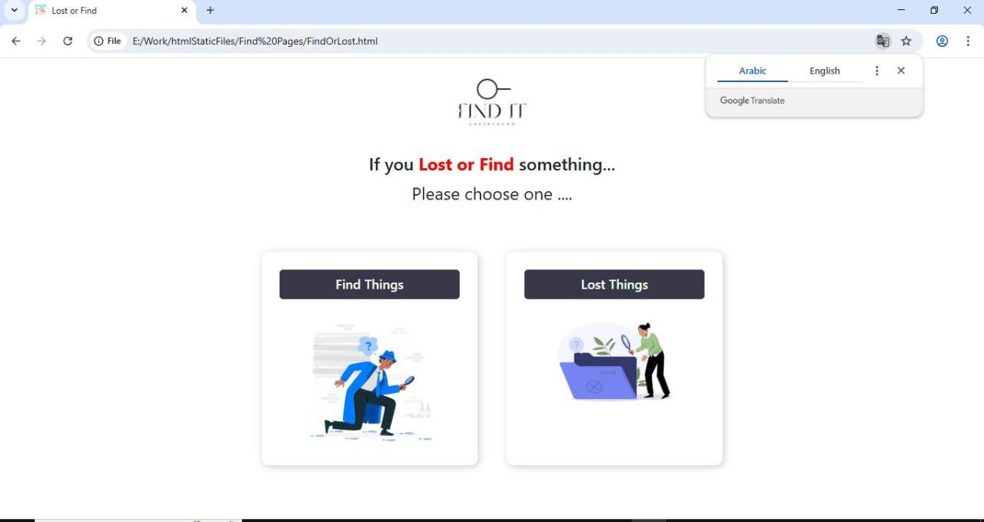

- The user can choose from: Phone or Card **for example chose Find class**

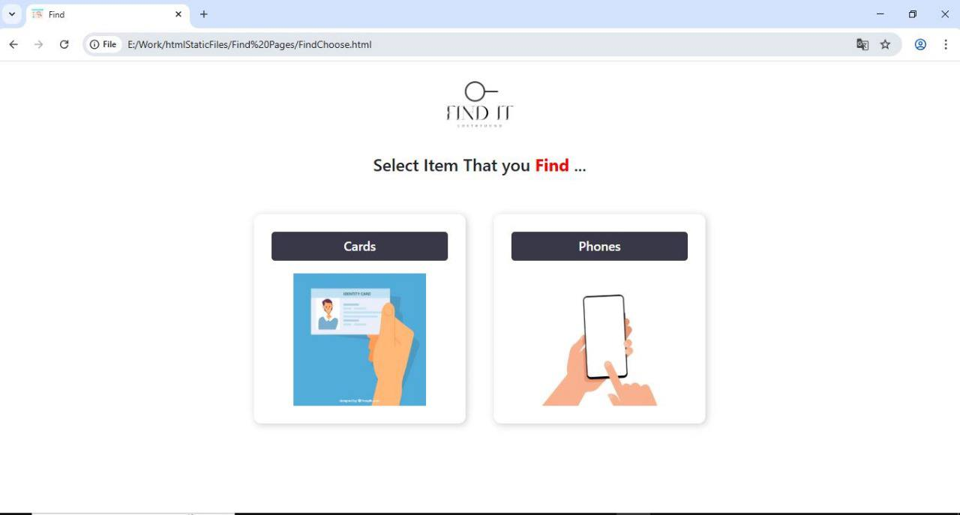

- Find Card: the page through which the user finds a personal card, so he fills in the empty boxes such as the name of the person inside the card, the national ID number, and some optional details such as the address of the place where it was found. Like the phone page, here he can also upload a picture of the card

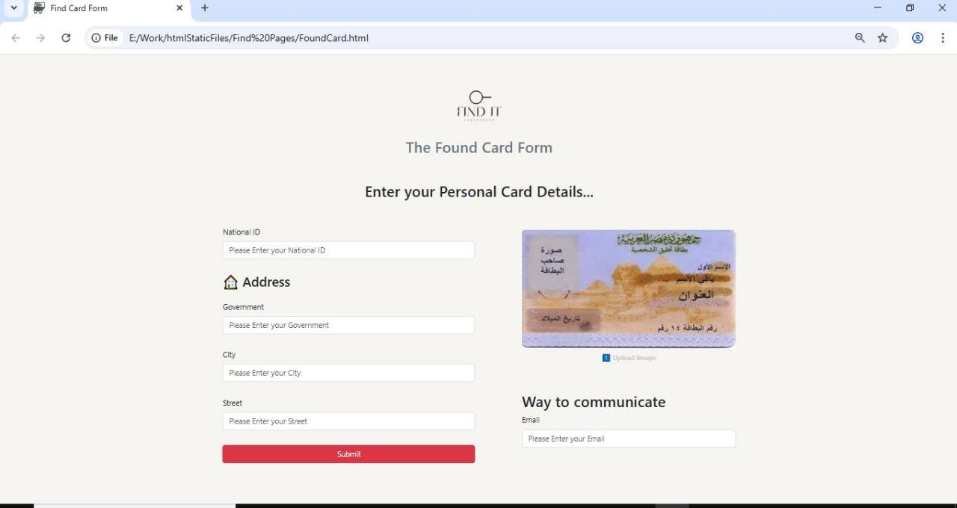

-Upload Card: This is the step in which the user uploads a photo of the card.

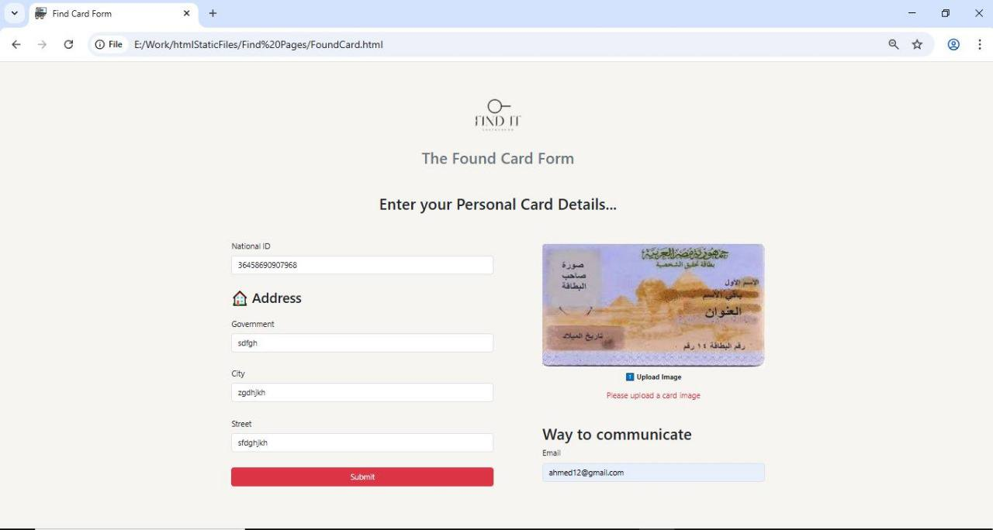

-Valid Card: A message appears confirming that the image has been uploaded and an option to upload another image.

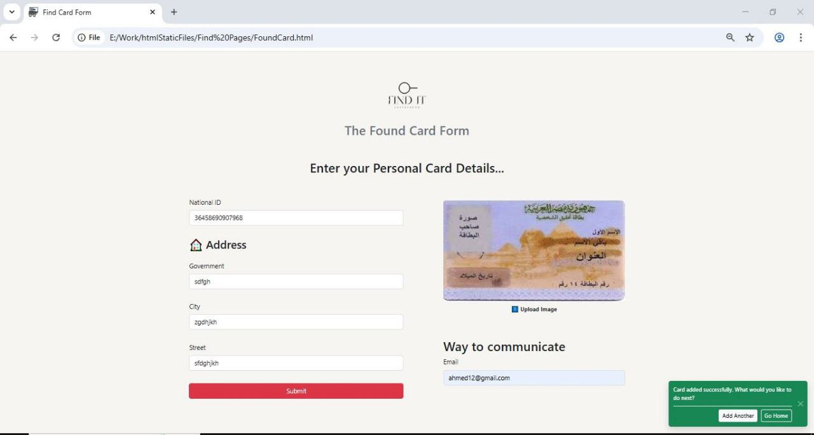

For example:

-Find Phone: a page appears with empty boxes that he must fill in with the phone brand, color, and some details about it. These are mandatory steps. He also adds the address of the place where the phone was found, which is an optional step. He can also include a picture of the found phone

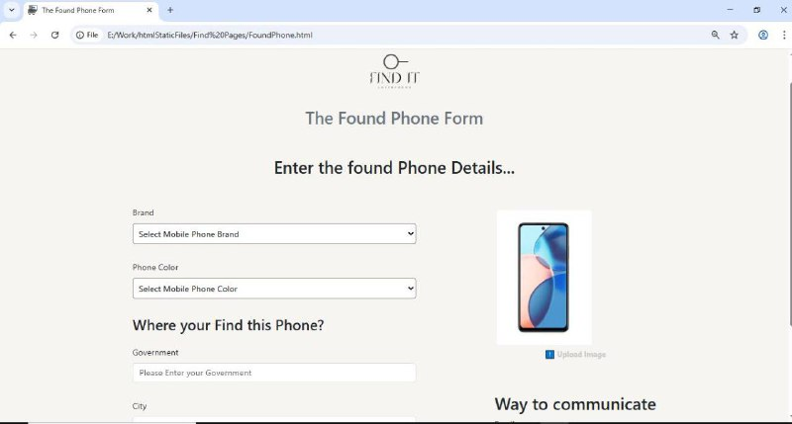

-Lost Phone with way to communicate by finder and loser

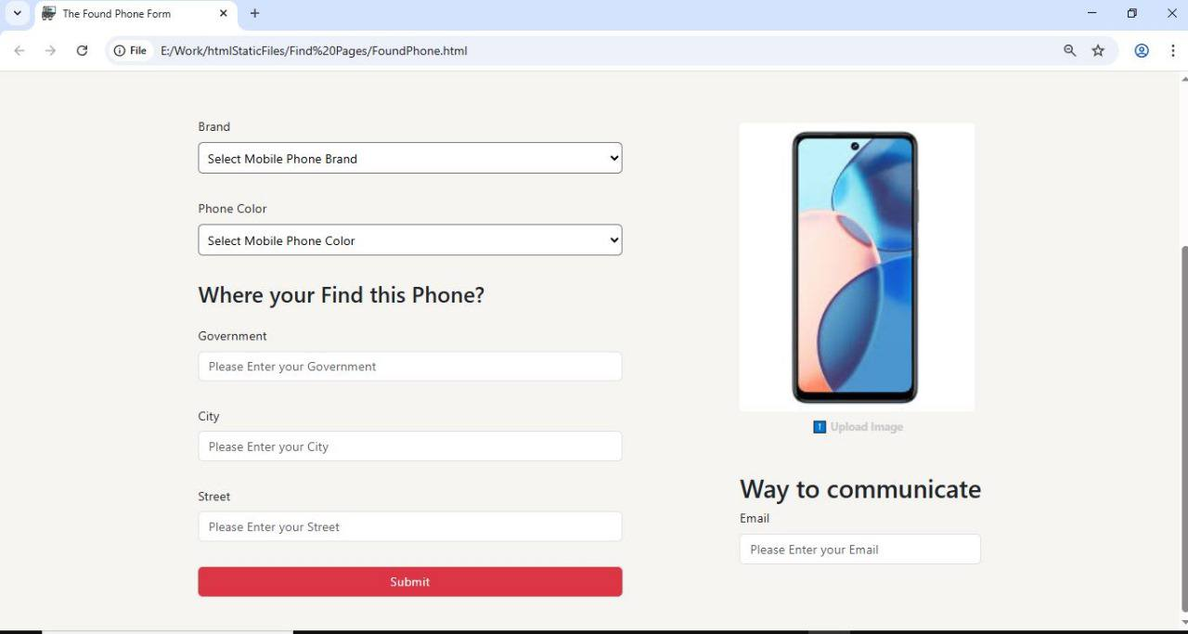

-Upload Phone image

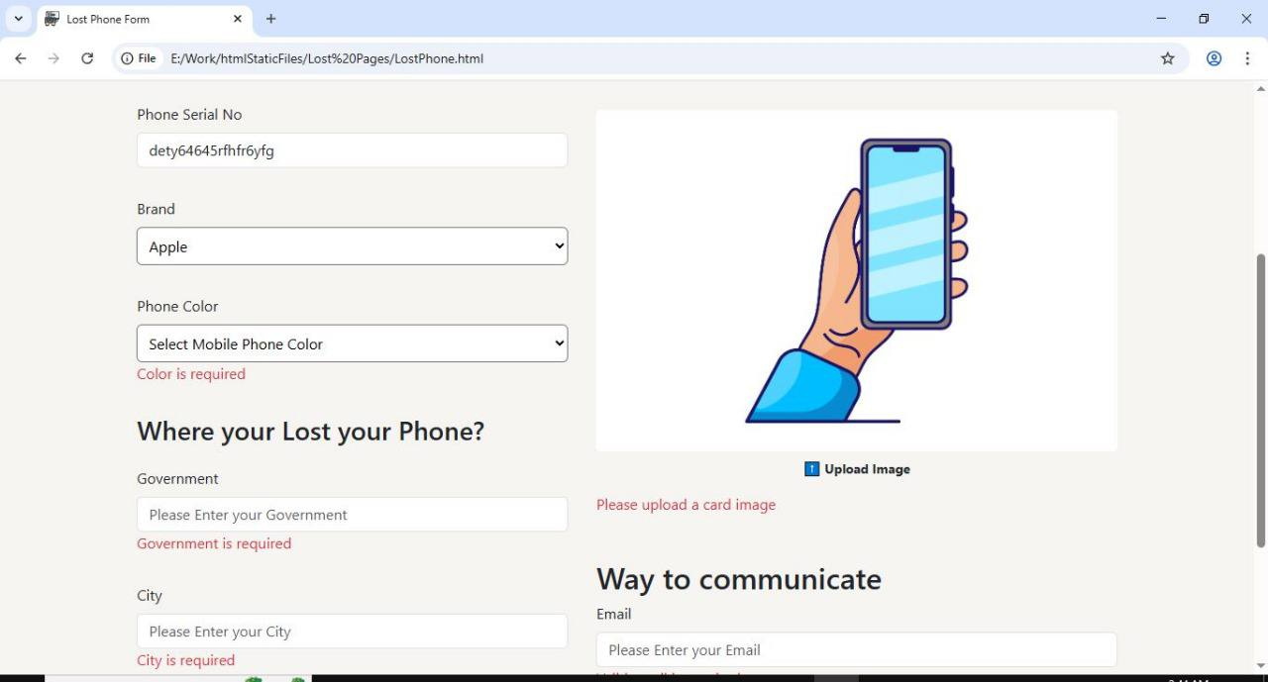

Similarity Match type**: text**

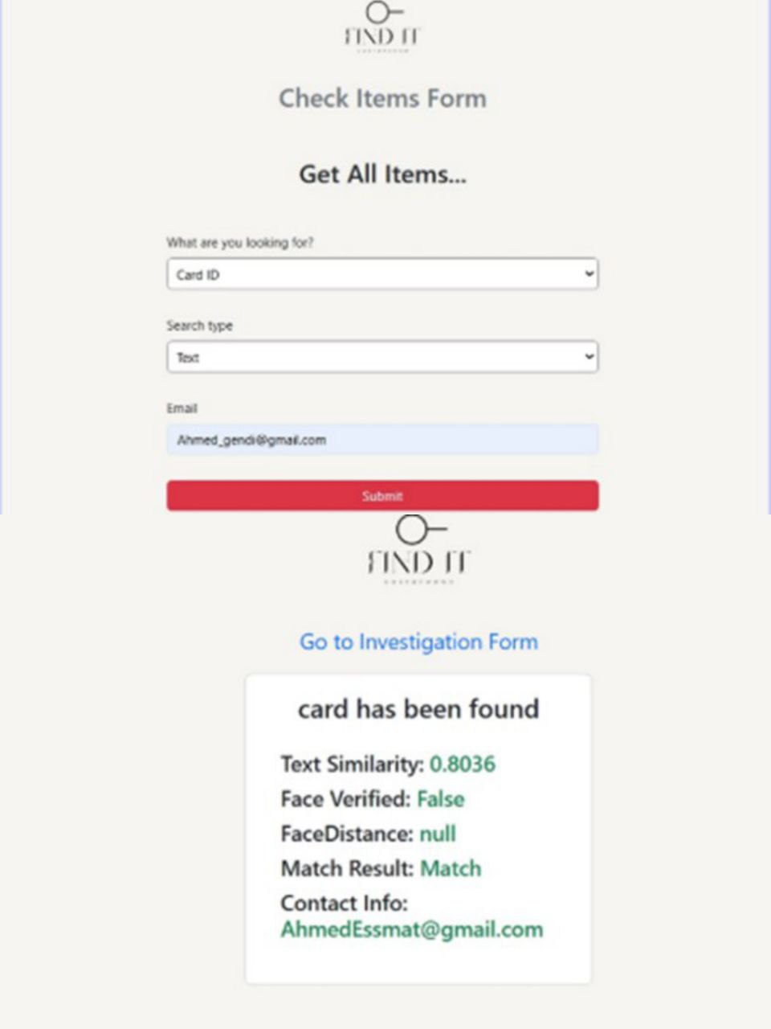

Similarity Match type: **image**

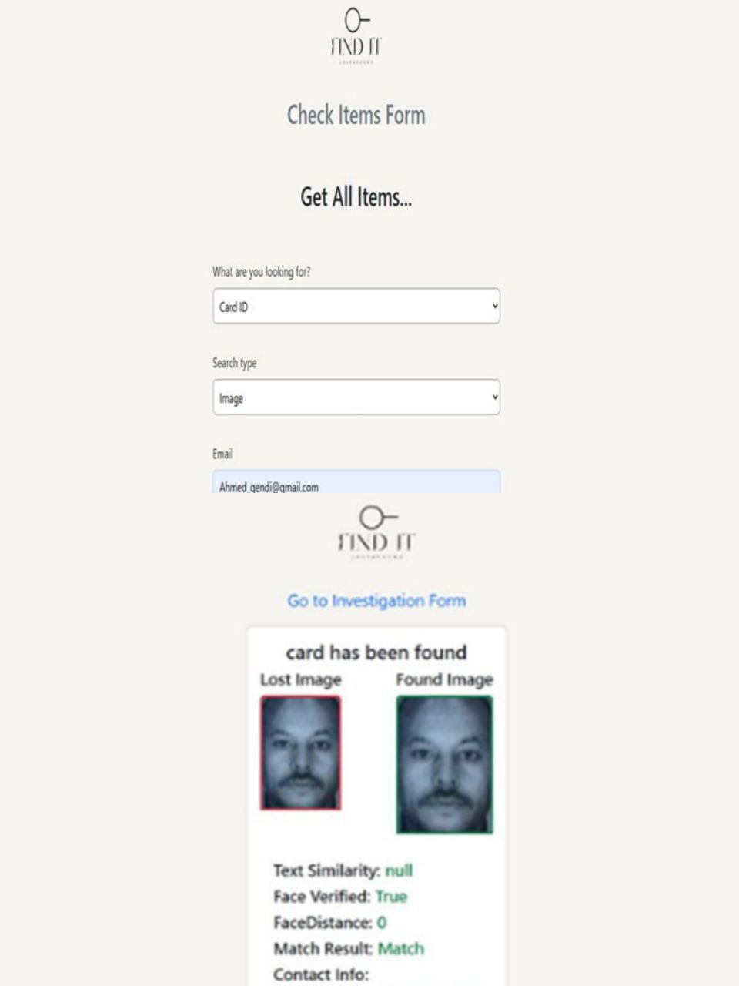

Similarity match type: **Both**

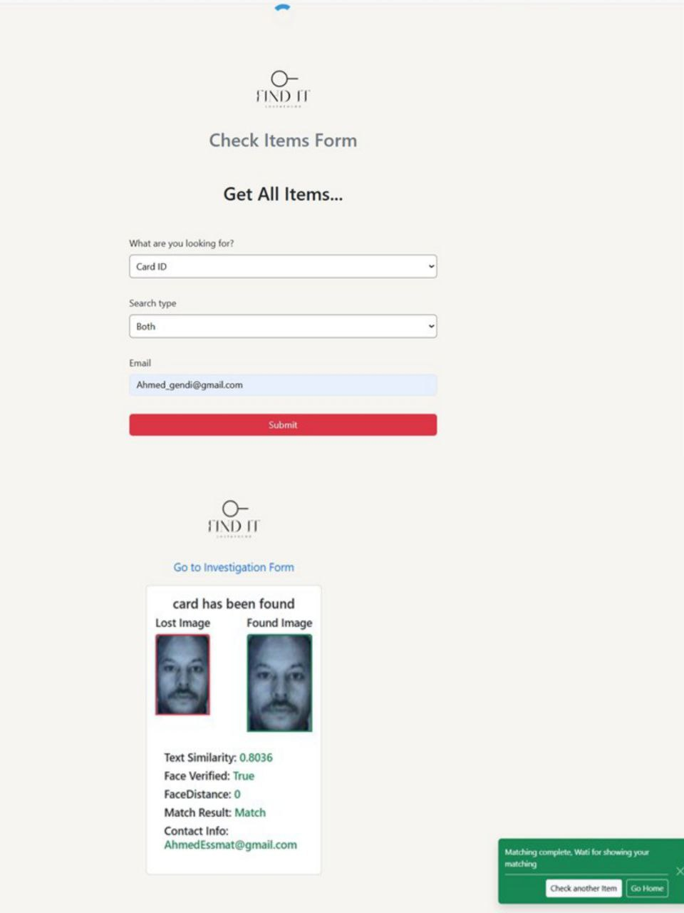

**Match type: text**

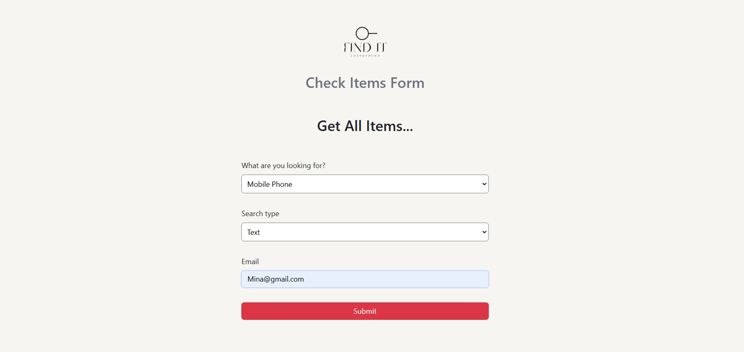

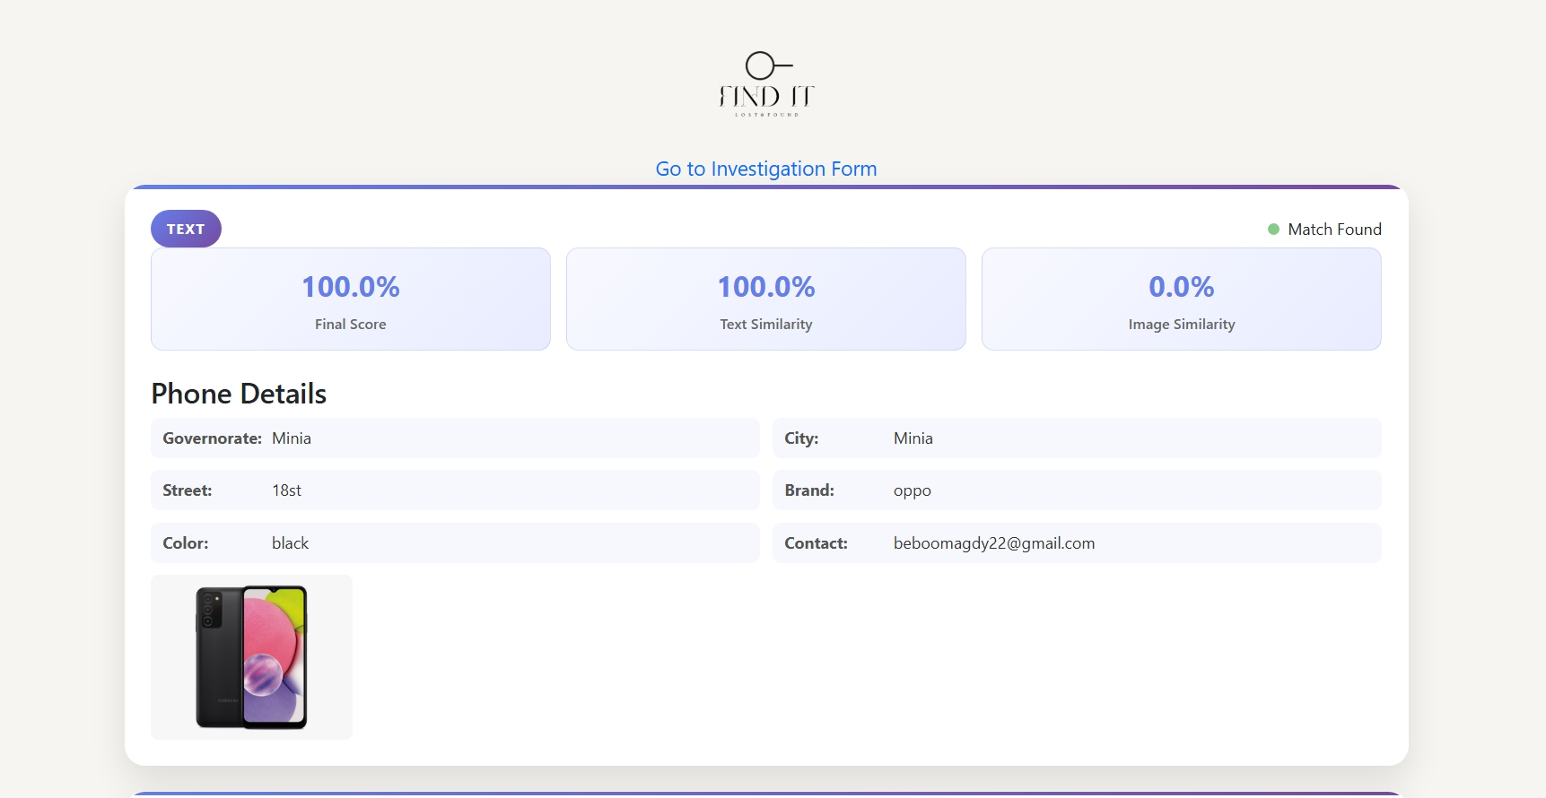

**Match type: image**

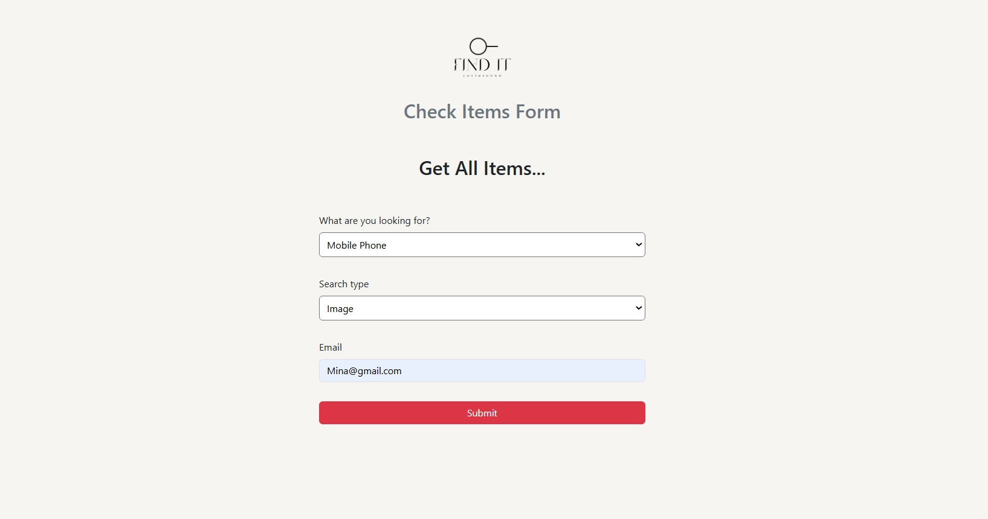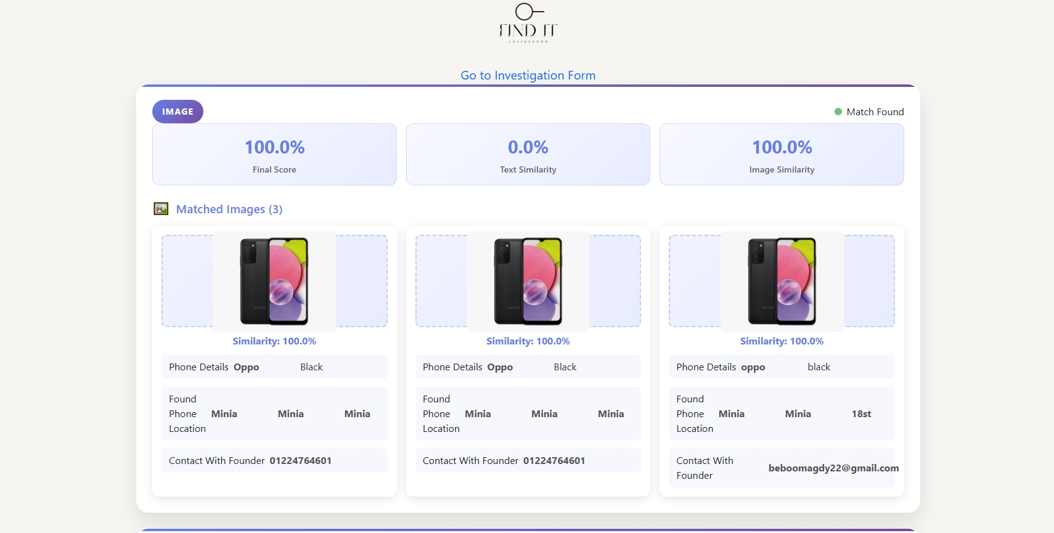

**Match type: both**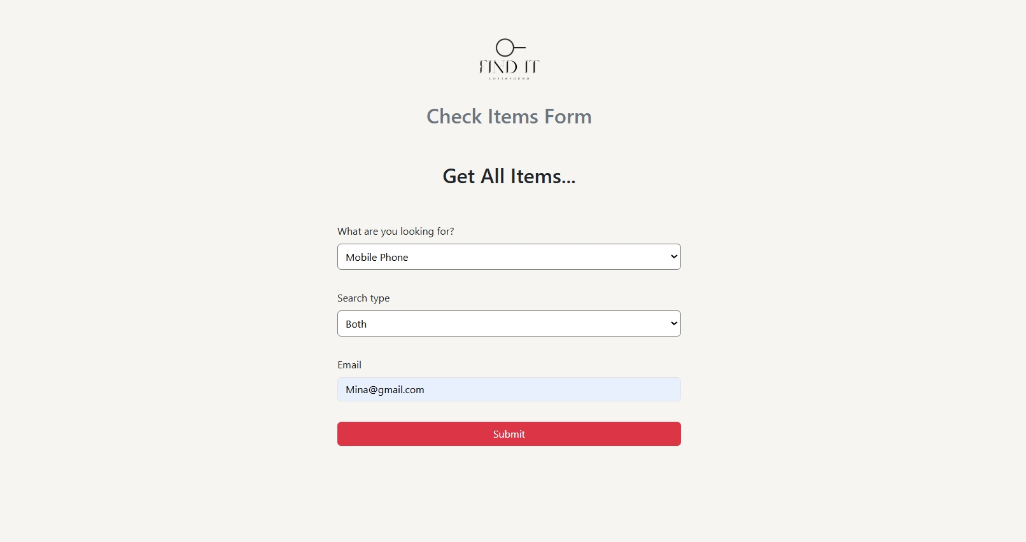

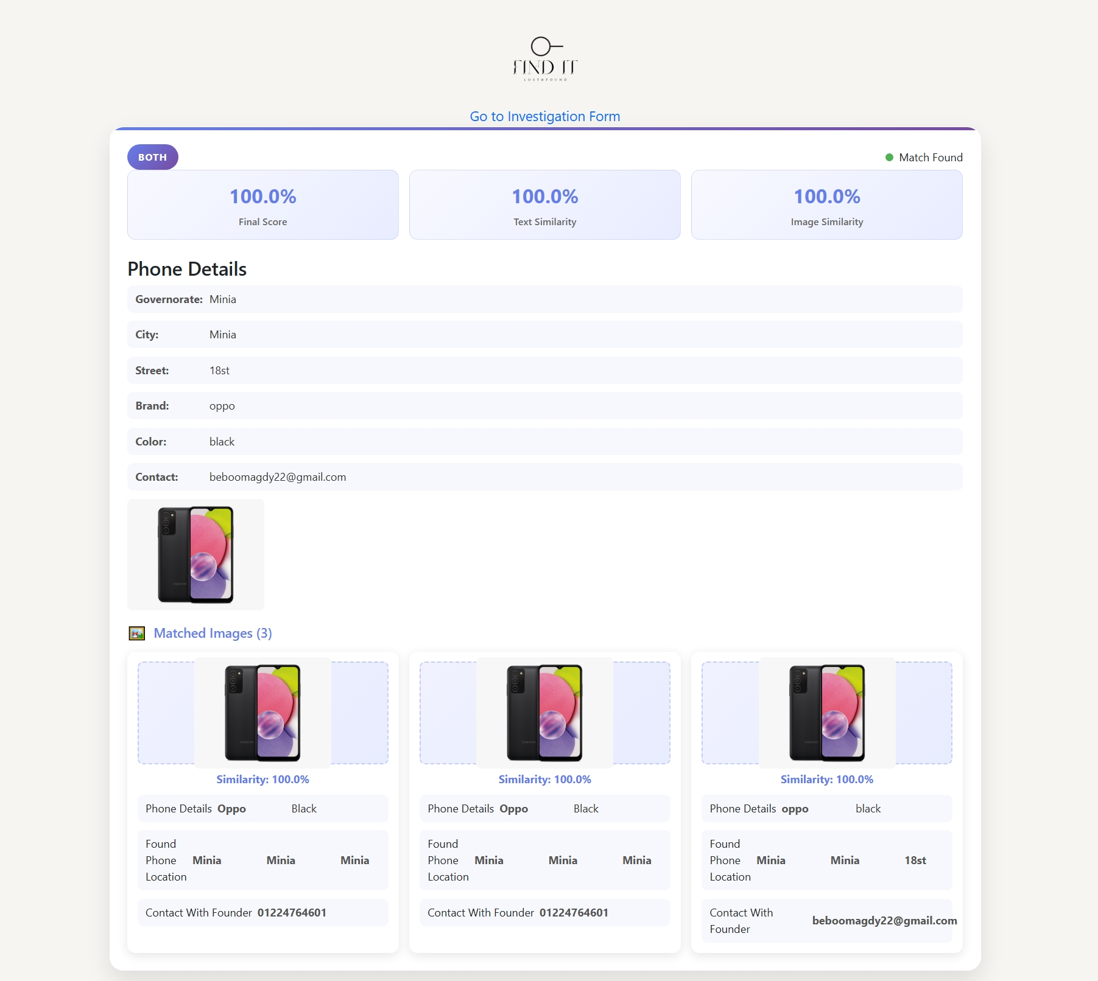

**4.3 Challenges faced and how they were resolved:**

The most challenging aspect of this project was integrating AI technologies such as recommendation systems and image recognition to match lost and found items accurately and selecting the most appropriate models that would deliver high accuracy and efficiency when dealing with real-world, inconsistent data.

Similarly we faced challenges in ensuring accurate recognition and matching of images uploaded by users, especially under varying conditions such as low resolution, poor lighting, or unconventional angles. These inconsistencies significantly affected the performance of the AI models.

To address these challenges, several solutions were implemented:

Multiple AI models were tested extensively, and the best-performing ones were selected based on their accuracy and speed. For instance, SentenceTransformer was employed for textual similarity tasks, while CLIP was used for image-to-text matching.

Realistic and diverse data was gathered from user reports and various public sources to enhance the reliability and robustness of the models.

For real-time object and face detection, YOLOv8 was utilized due to its fast and accurate performance.

High-accuracy face matching and verification were achieved by integrating DeepFace with the ArcFace model.

Chapter 5

Testing & Evaluation

5.1 Testing strategies (unit testing, integration testing, user testing).

5.2 Performance metrics (accuracy, speed, scalability, etc.).

5.3 Comparison with existing solutions (if applicable).

**5.1 Testing strategies (unit testing, integration testing, and user testing):**

1-Introduction: This report summarizes the testing activities for the Lost & Found API. The project uses Swagger (via Swashbuckle) to auto-generate interactive API documentation, enabling real time testing, validation, and parameter inspection.

Testing strategies applied: - Unit Testing - Integration Testing - User Testing

2-Unit testing:

Purpose Validate each endpoint’s behavior in isolation.

Tools: - unittest / pytest (Python) - FastAPI TestClient - Swagger UI for endpoint-level execution and schema inspection

Coverage Examples:-

Endpoint POST /api/Auth/Login POST /api/Find_Card/Add_Find_Card GET /api/Find_Phone/Get_All_Founded_Phones POST /api/Checking_For_Items/CardMatch Scenario Login with correct Valid card data Retrieve all phones Matching valid data Result Returns token Card saved List returned Match found

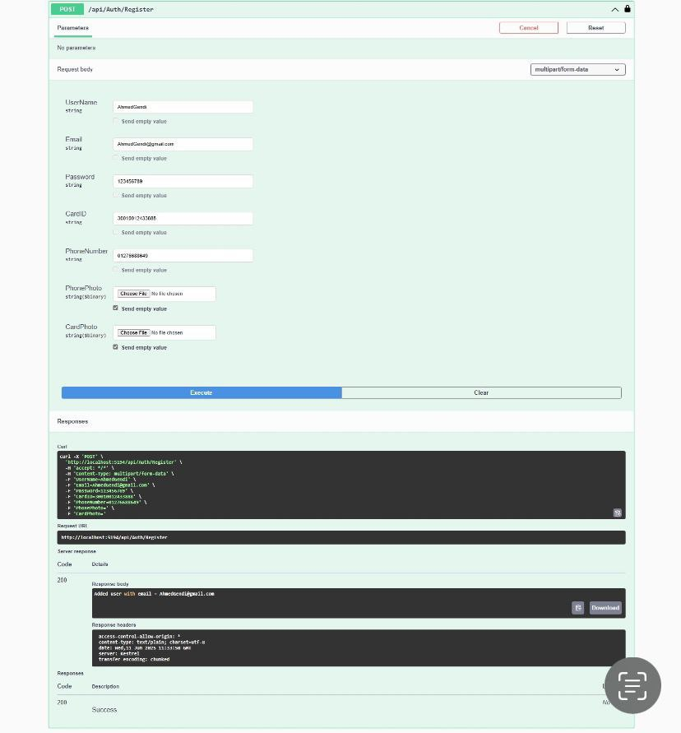

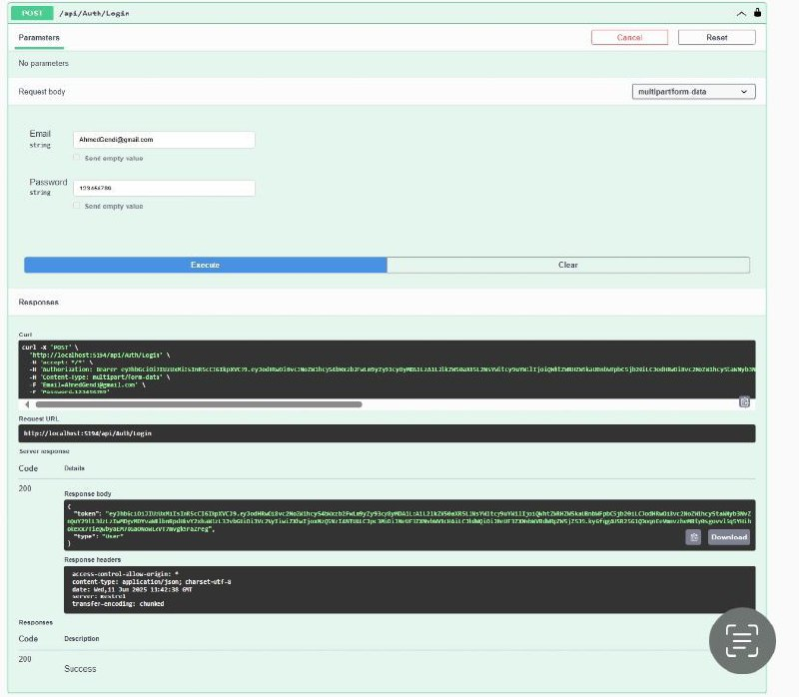

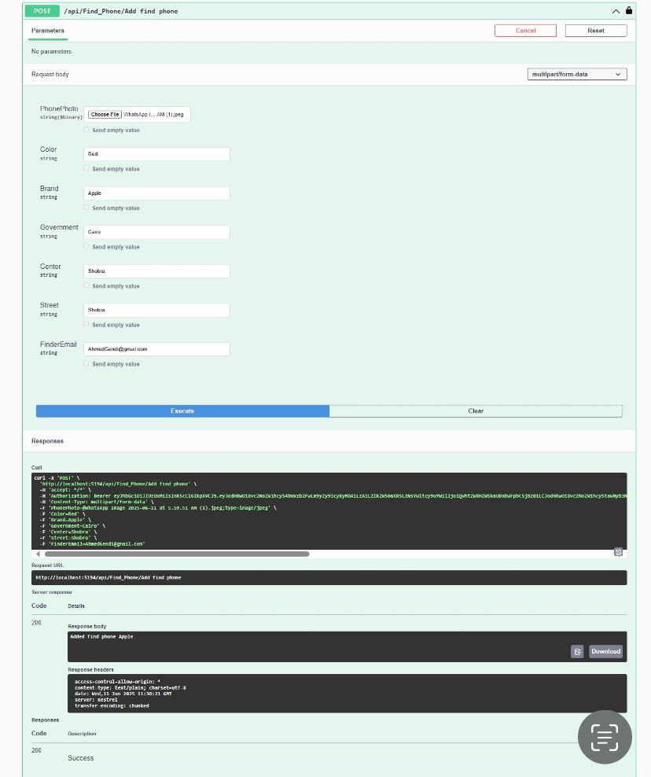

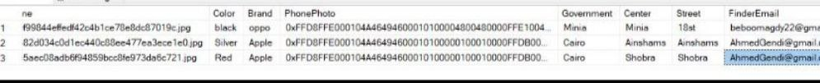

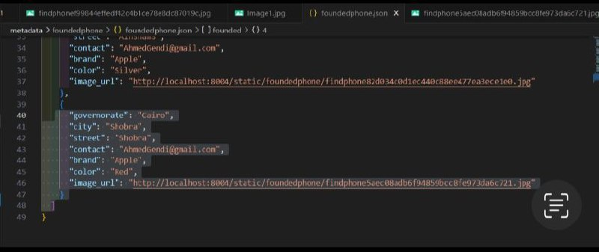

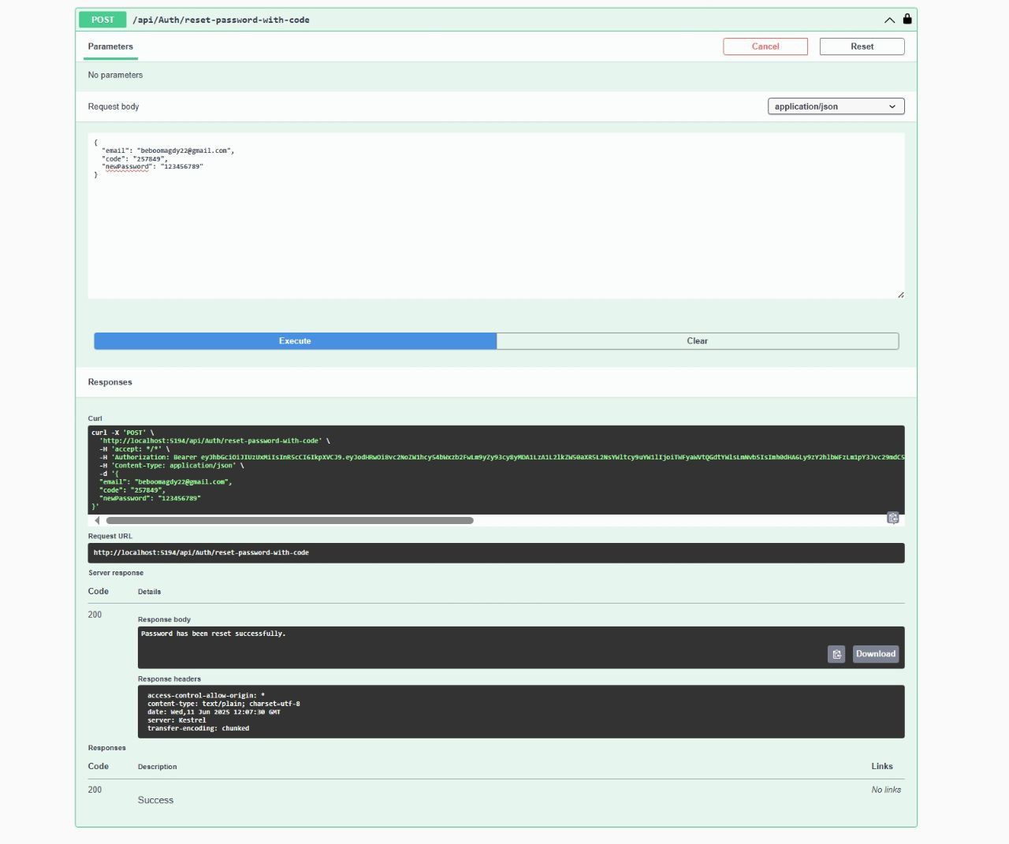

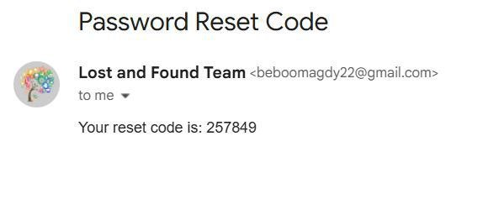

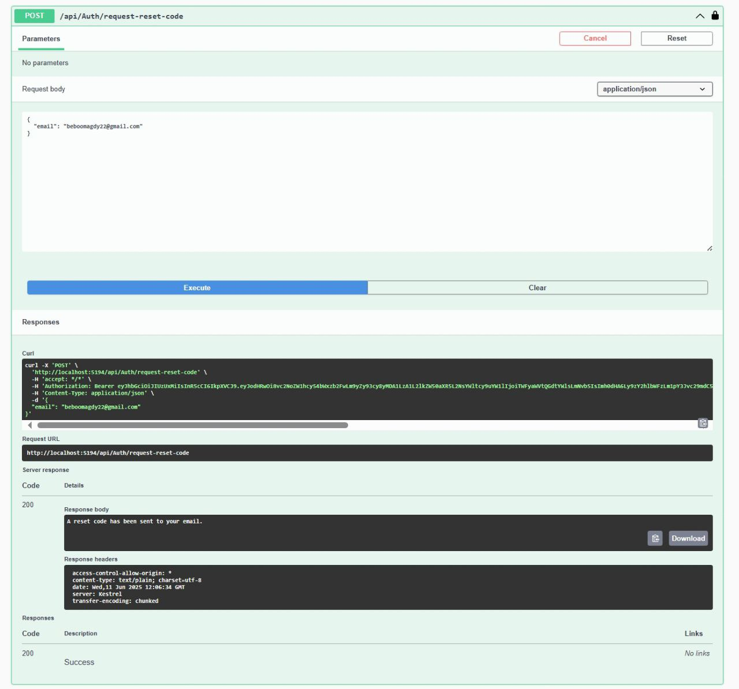

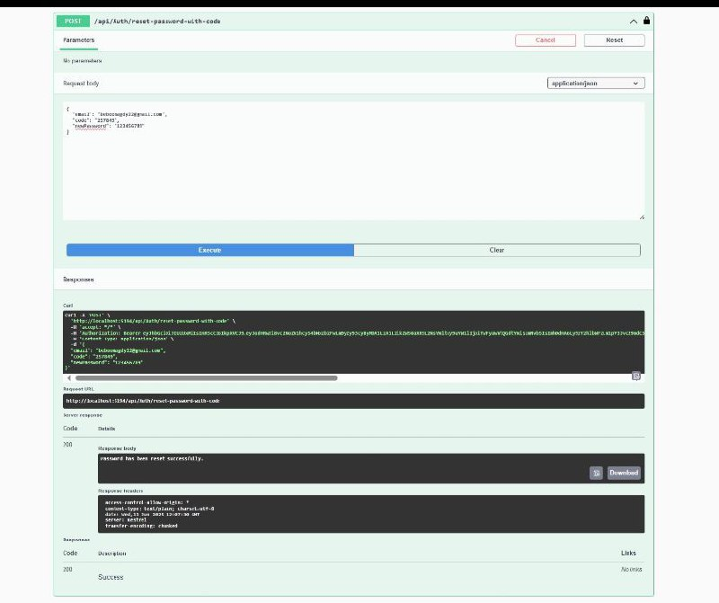

**3-**Integration Testing

Purpose: Check interoperation between APIs, database, and logic.

Tools: Swagger UI (for real-time flow tests) - Postman for batch testing - pytest + TestClient

Flow Scenarios: Flow Add lost phone → matchPhone Register → Login → Add Card Description Add data then test match logic Multi-step user flow Add + Update + Delete Card Full lifecycle validation Result Working correctly All stages work Successful

User Testing 4.1 Purpose Identify UX/UI issues and validate from user’s perspective. he user creates an account by adding the user name, email, password, phone number, and national ID number.



The user logs in by adding his email and password



In the event that a person finds a card, he enters the national ID number and the address where he found this card, or uploads a picture of this card, then writes his email address in order to contact the lost person in the event that a match is found.

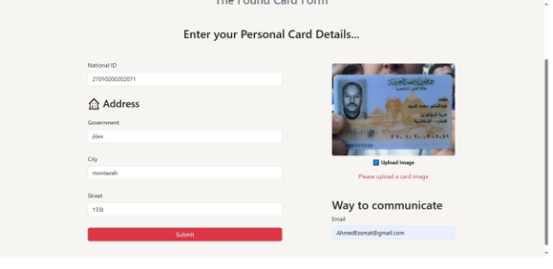

in the event that a person loses a card, he enters the national ID number and the address where he lost this card, or uploads a photo of this card, then writes his email address in order to communicate with the person who found it in the event that a match is found.

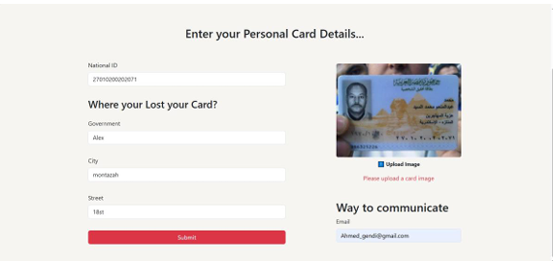

The user who lost something enters the investigation page and specifies what he lost, then specifies whether he uploaded a photo or wrote texts, then writes his email.

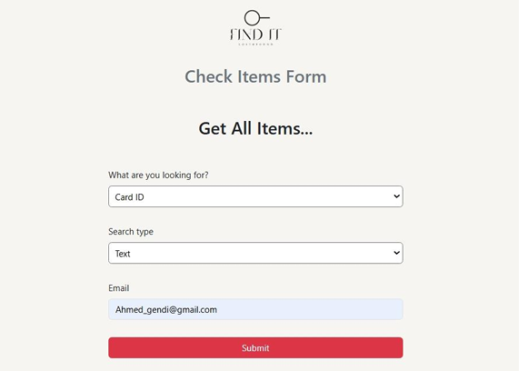

The investigation result appears here via text in the event of a match, along with the similarity percentage and the email of the person in question, so that they can communicate with each other.

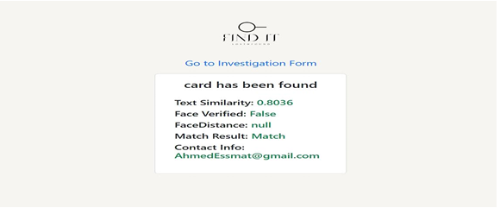

The result of the investigation appears here, using the images, in the event of a match, along with the similarity percentage. The image and the email of the person in question are also shown, so that they can communicate with each other.

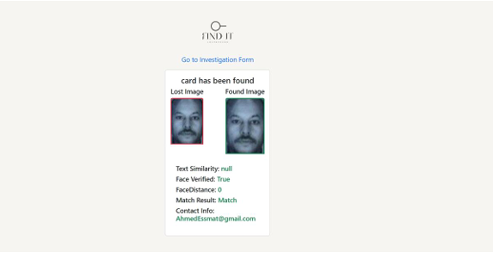

The user who lost something enters the investigation page and specifies what he lost, then specifies that he uploaded a photo and wrote texts together, then he writes his email.

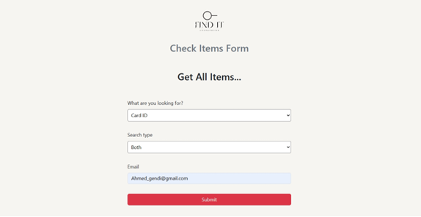

The results of the investigation are shown here, using both images and text. If a match is found, the similarity percentage is also shown. The image and email address of the person in question are also shown, so they can communicate with each other

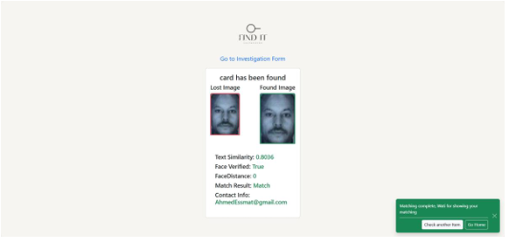

**5.2 Performance metrics (accuracy, speed, scalability, etc.):**

**Evaluation of YOLOFaceV8 Model for Face Detection on Identity Documents**

During the evaluation of the YOLOFaceV8 model on various identity documents (such as Egyptian national ID cards and U.S. passports), we observed significant variation in detection accuracy depending on image quality, layout complexity, and text interference.

**Phase 1: Initial Observations**

* The model produced low accuracy in early trials, with detection confidence scores like 0.56 and 0.29 (as shown in the Egyptian ID example).
* In some cases, bounding boxes were misplaced, overlapping with text or partially covering the face.
* To improve results, we had to manually guide the detection using refined bounding boxes focusing only on the face.

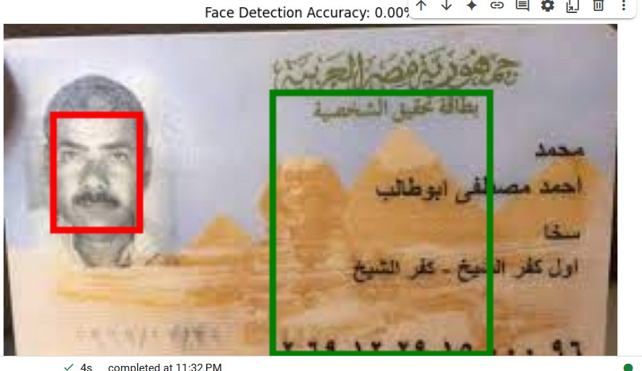

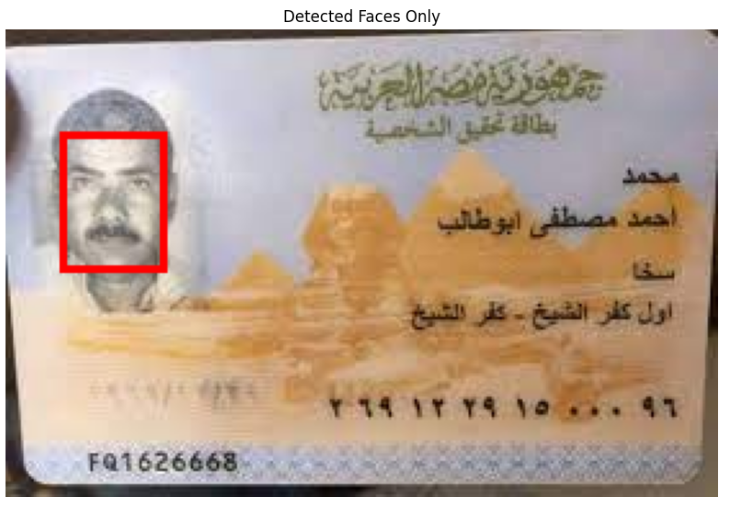

* 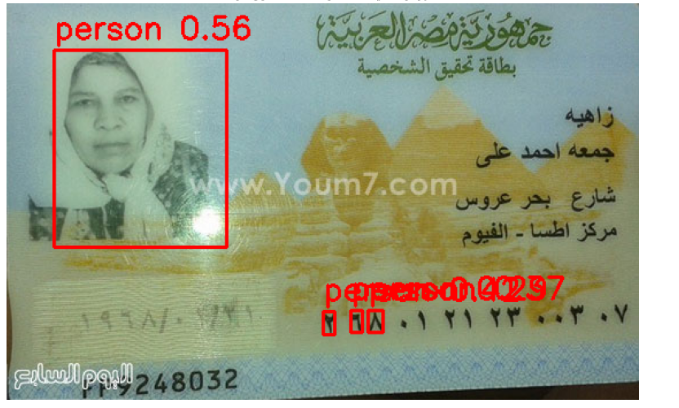

**Intermediate Improvements**

Applied tighter bounding boxes centered on the facial region.

Implemented a confidence threshold to filter out weak detections.

Enhanced preprocessing steps (e.g., image resizing, noise filtering).

These adjustments led to improved detection scores, reaching 0.79 in some cases.

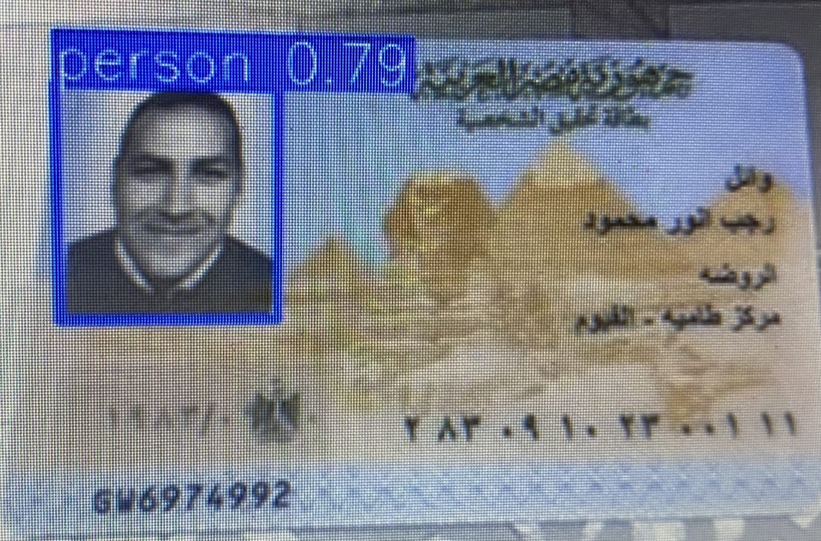

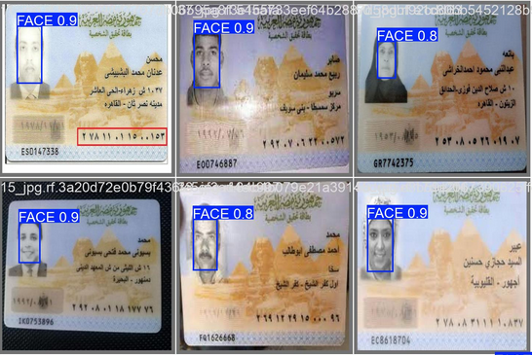

**Final Results:**

After refining the input and settings, the model achieved high accuracy, with detection confidence scores reaching up to 0.90 and even 100% in optimal conditions (as shown in the U.S. passport example).

The model showed strong performance on documents with clear and consistent layouts, minimal noise, and well-lit facial images.

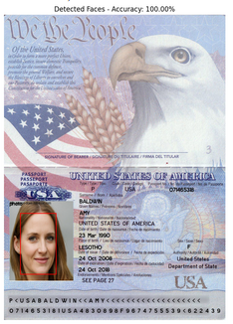

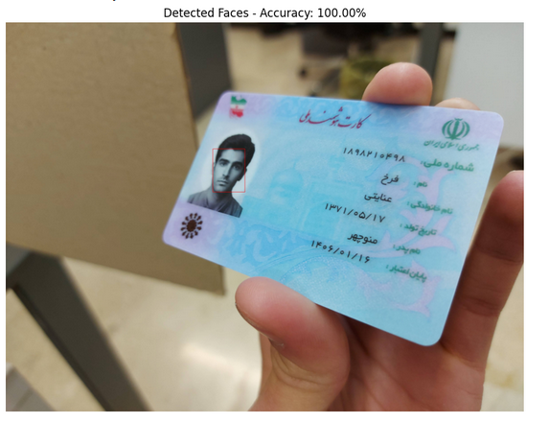

**Evaluation of DeepFace Model for Face Verification**

In the beginning, when using DeepFace for comparing facial identities across different ID documents, the results were not reliable. The model often failed to correctly match the same person across different images, especially when there were differences in lighting, image quality, or facial angles.

**Initial Results:**

* The default settings led to inaccurate comparisons.
* It often gave false positives or false negatives, even when the faces clearly belonged to the same or different individuals.
* This was due to the limited effectiveness of the default embedding and distance metric being used.

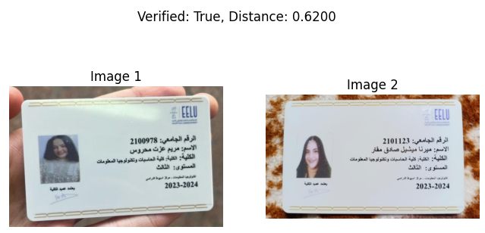

**Improvements:**

* We switched the backend to ArcFace, which generates more discriminative facial embeddings.
* Also, we changed the distance metric to Euclidean (L2) instead of the default cosine similarity.
* After this change, the model's performance improved significantly.
* Face comparisons became much more accurate and stable, even across documents with different lighting or image types.
* 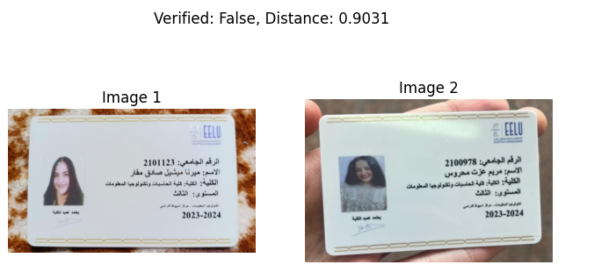

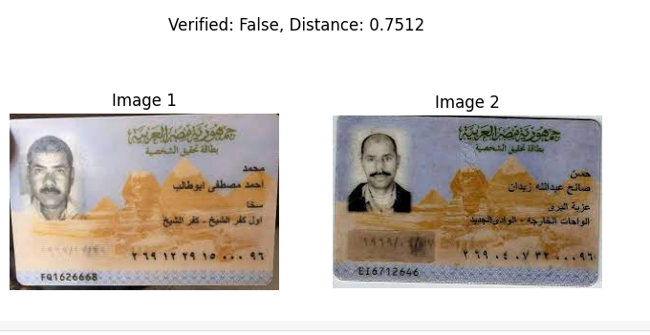

**Final Outcome:**

**With the combination of ArcFace + Euclidean L2 distance, DeepFace was able to:**

* + Correctly match the same person across ID types.
  + Distinguish different people more reliably.
* The system now works effectively for face verification in identity document analysis

**9.9 Evaluation Metrics for YOLOv8 Face Detection:**

To assess the performance of the YOLOv8 model trained for face detection on identity cards, the following evaluation was conducted on a validation dataset using Roboflow:

**Accuracy (mAP@0.5):** 0.995

**Generalized Accuracy (mAP@0.5:0.95):** 0.862

**Precision:** 0.992

**Recall:** 1.0

Response Time (Inference): ~273 ms per image on CPU

These results indicate that the model is highly accurate and capable of detecting faces with minimal false positives and zero missed detections in the test set

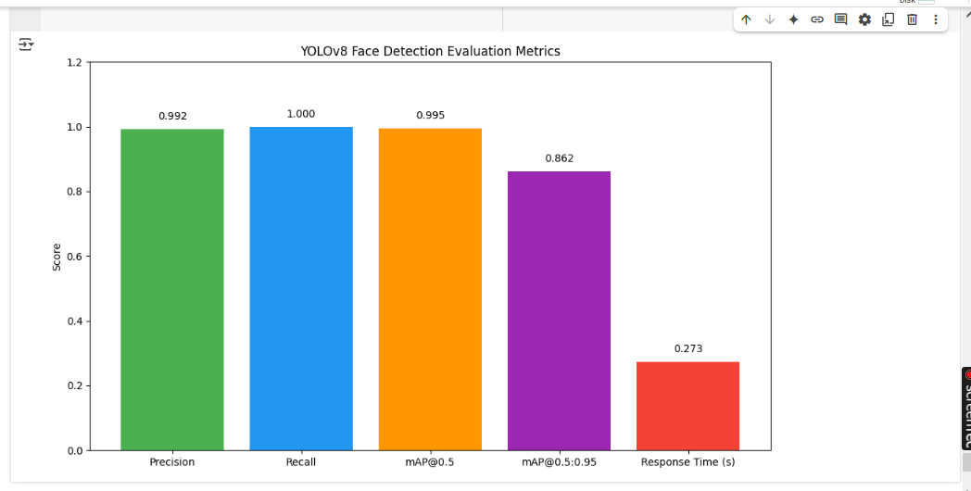

**Integration of YOLOFaceV8 with DeepFace for Enhanced Face Verification**

To improve the overall performance of identity verification from document images, we **combined YOLOFaceV8 (for face detection) with DeepFace (for face comparison)** into a unified pipeline.

**Why the Integration Was Needed:**

* YOLOFaceV8 alone can **detect and locate faces**, but it doesn't compare or verify if two faces belong to the same person.
* DeepFace can **compare facial features**, but it performs better when faces are **accurately cropped and aligned.**
* By using YOLOFaceV8 first to **precisely extract facial regions**, then passing them to DeepFace, we were able to improve verification accuracy.

**The Combined Pipeline:**

1. **YOLOFaceV8** detects the face(s) in each document image.
2. The detected faces are **cropped and preprocessed.**
3. **DeepFace** with **ArcFace + Euclidean L2** is then used to compare the facial embeddings.
4. A similarity score is generated to determine whether the two faces belong to the same individua

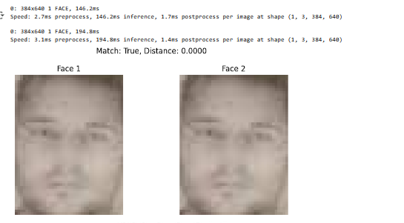

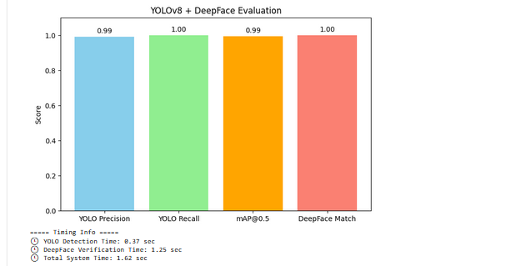

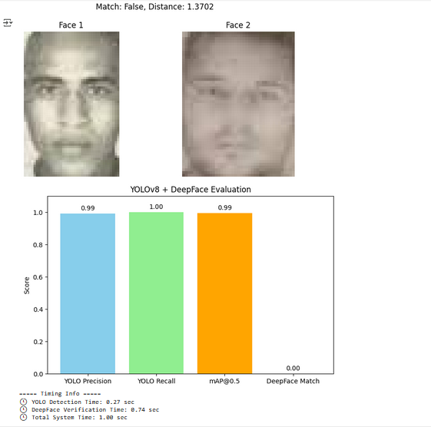

**Results of the Fusion:**

* YOLOFaceV8 was used to **detect and crop the face region** from each document image. This ensured that only the relevant facial area was passed to the comparison stage.
* The cropped face images were then **fed into DeepFace**, which performed the comparison using the ArcFace backend and Euclidean (L2) distance metric.
* This approach helped reduce noise from the background, text, and other elements in ID documents, which previously affected DeepFace's accuracy.
* As a result, the system produced **more accurate and consistent face matching**, even when comparing images from different types of documents or under varying lighting conditions.

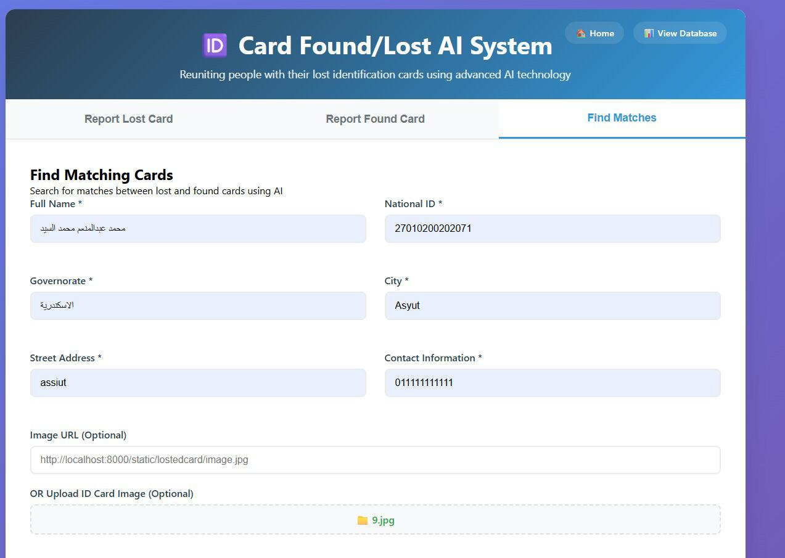

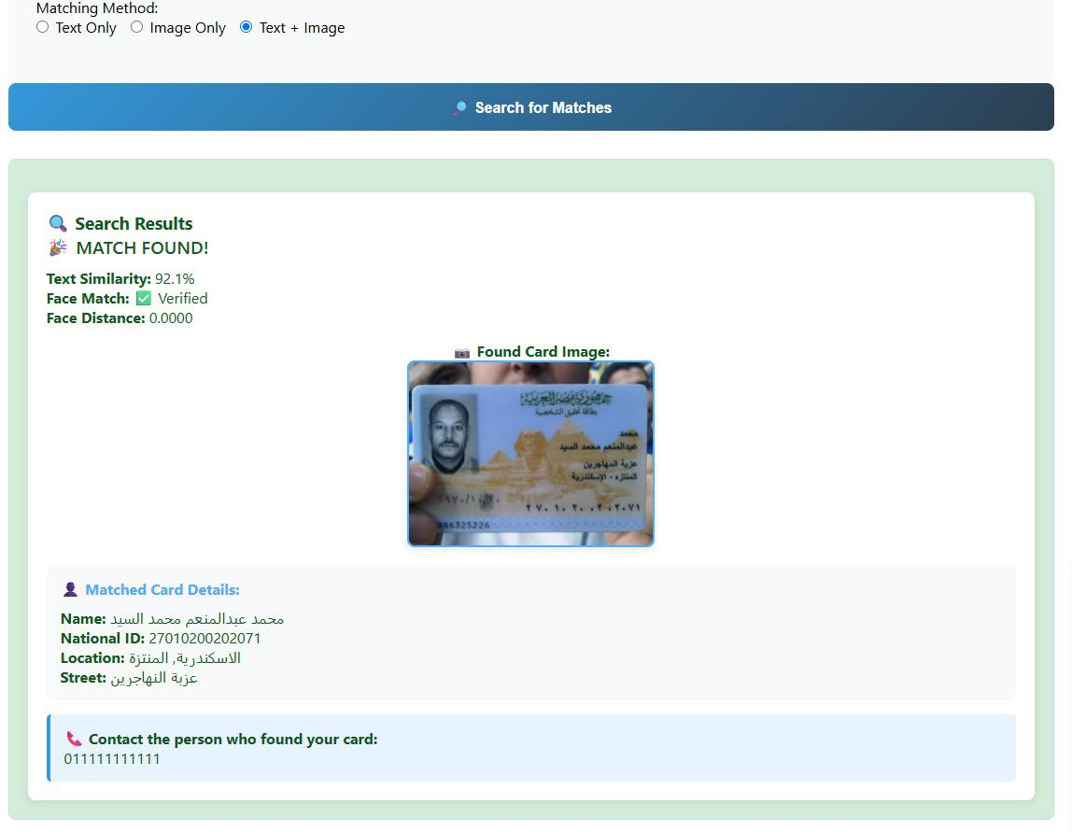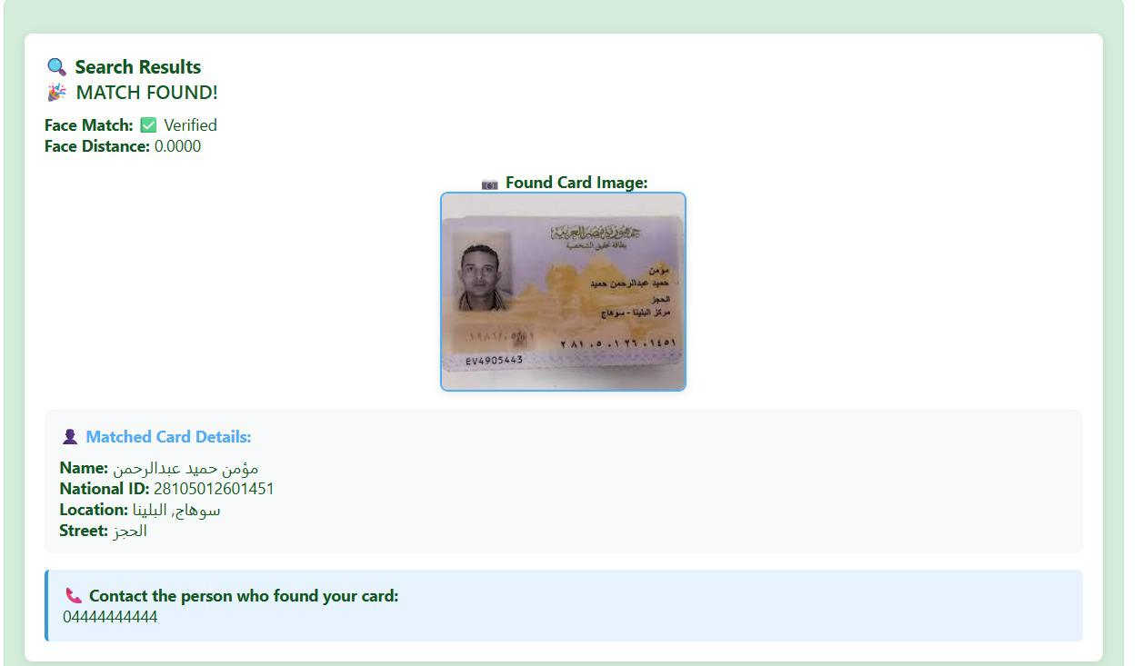

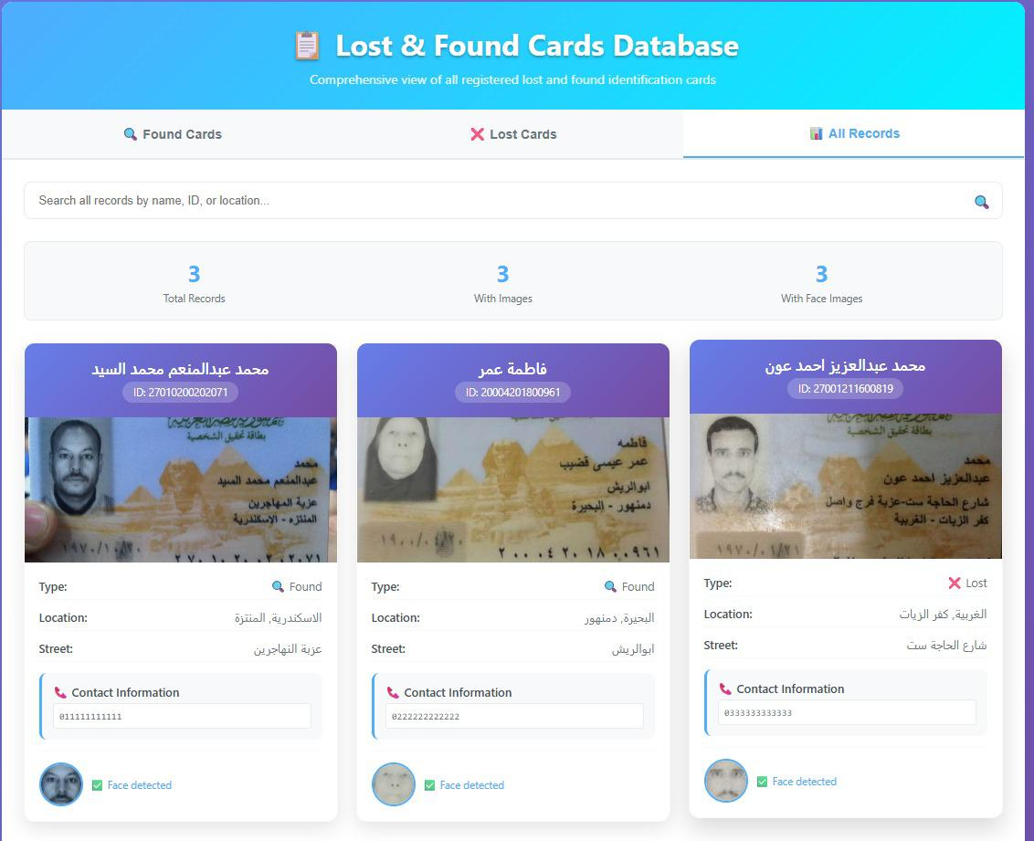

**Evaluation of CLIP Model for Image-to-Image Matching**

Initially, we used **CLIP** (Contrastive Language–Image Pretraining) to compare document images directly, especially facial images, by generating embeddings for each image and measuring similarity.

**Initial Approach:**

* CLIP was used to **compare one image with another** directly.
* The matching process was **slow and less scalable**, especially as the number of images increased.
* No indexing was applied, so the system checked **every image one** by one, which was not efficient for larger datasets.

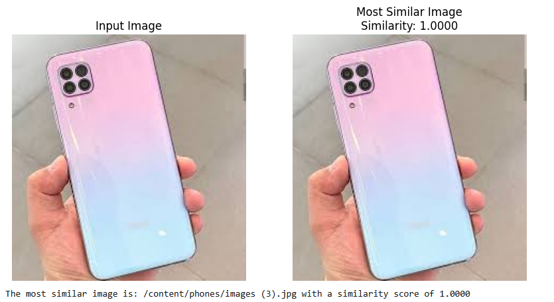

**Improvements with FAISS:**

* To improve performance, we integrated **FAISS (Facebook AI Similarity Search)** with CLIP.
* Instead of brute-force comparison, FAISS builds an **index of all image embeddings**, making similarity search much faster and scalable.
* This allowed us to search for the **most similar images efficiently**, even in large collections (e.g., across a mobile gallery or database of documents).

**Using Top-K Accuracy:**

We applied **Top-K retrieval**

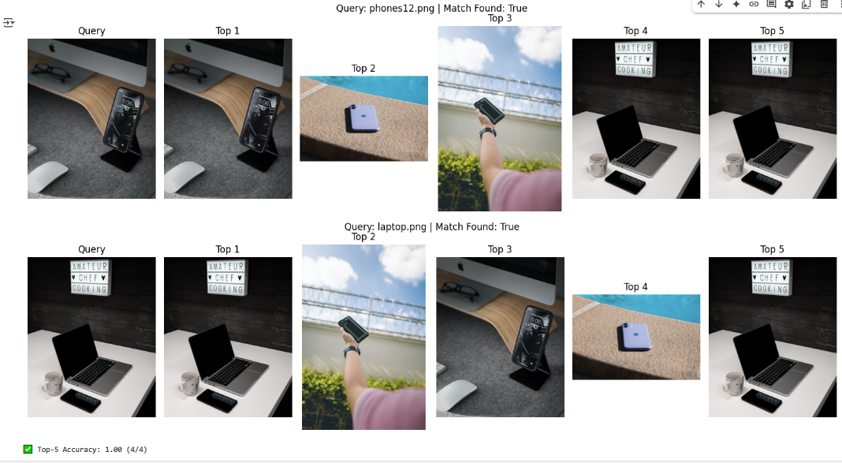



* the system returns the **Top 3 most similar images** to a given query. 
* We performed an evaluation using Top-K accuracy to better assess the model’s reliability. Specifically, if the correct image appeared within the top 3 predictions, it was counted as a successful match. This assessment was conducted by comparing the predictions against the ground truth labels
* **Top-K accuracy** provided more insight into the model’s reliability — if the correct image appeared in the top 3, it was still considered a successful match



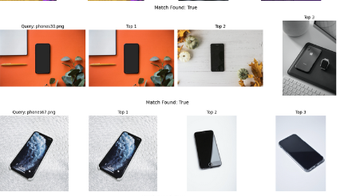

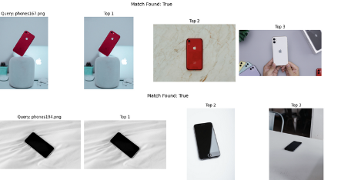

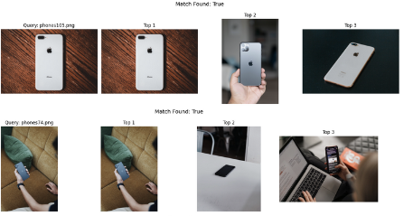

**Evaluation Sentence Transformers Model:**

We evaluated the performance of the Sentence Transformers model for text comparison tasks. Initially, the model used a smaller architecture (L6), which showed relatively weak results in accurately matching texts.

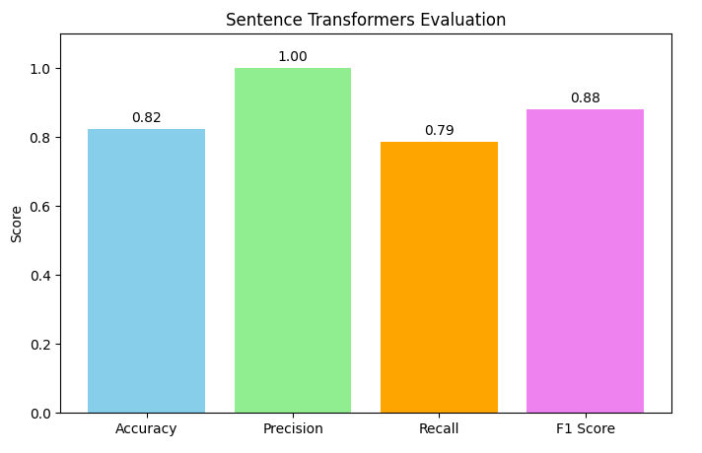

To improve the model’s performance, we increased the model size to L12, which significantly enhanced the quality of the embeddings and consequently the matching accuracy.

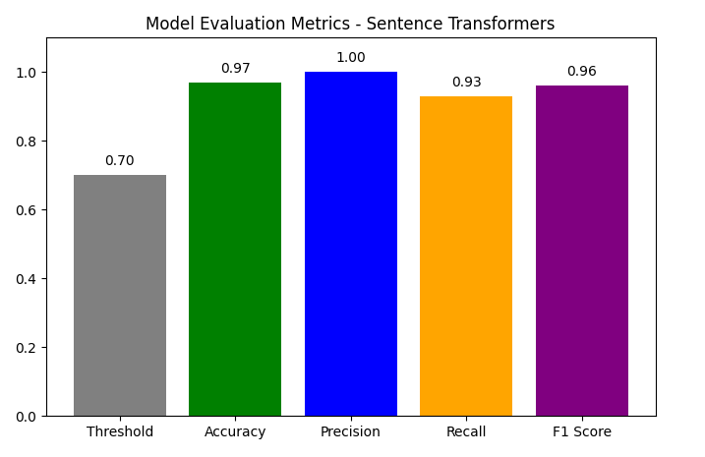

Our evaluation metrics included:

**Threshold**: We applied a similarity threshold of 0.7 — predictions with scores above this value were considered positive matches.

**Recall**: Measures the model’s ability to find all relevant matches. This metric was crucial because missing relevant matches is more detrimental in our application.

**Precision**: To ensure that the matches found were mostly correct.

**F1 Score**: To balance between precision and recall.

**Accuracy**: Overall correctness of the predictions.

By comparing the results from L6 and L12 models, we observed a clear improvement, especially in recall and F1 score, indicating that the larger model (L12) is more reliable for our text matching tasks

**5.3 Comparison with existing solutions (if applicable):**

|  |  |  |
| --- | --- | --- |
| Platform | Methodology & Features | Limitations |
| TROOV.com | - Location-based filtering - Manual item matching - Basic keyword search - Simple UI | -Lacks  AI recommendations - No real-time matching - Limited advanced search options |
| PAAYA | - Basic location/category filtering - Manual item reporting - Simple user interface | - No recommendation system - No chatbot or automation - Limited multimedia |
| Lostings.com | - Keyword-based matching - Manual categorization - News and video content for engagement | - No AI integration - Limited geographic reach - No chatbot or auto-matching |
| Lost & Found | -Community-based reporting - Advanced search and filters - Emphasis on keyword matching | - No AI support - No real-time matching - Lacks direct messaging system |
| FindMyLost | - Recommendation system included - Real-time notifications - Strong search filters | - Complex interface - Limited AI capabilities (only basic matching) |

Key Differentiators in Our System:

AI-Powered Recommendation Engine: Uses both content-based and collaborative filtering to provide smart matching of lost and found items.

Image Recognition & Matching: CLIP and DeepFace technologies enhance matching accuracy based on images.

User Notifications: Real-time alerts when matches are found.

Ownership Verification: Using national ID and image-based validation to ensure trust and security.

Hybrid Search & Recommendation Integration: Users can actively search and passively receive suggestions.

Chapter 6

Results & Discussion

* 1. Introduction
  2. Summary of findings.
  3. Interpretation of results (Did the project meet its objectives?).
  4. Limitations of the proposed solution.

**6.1 Introduction:**

The project aimed to create a user-friendly, AI-powered platform that facilitates the process of reporting and recovering lost and found items. This chapter summarizes the outcomes of the implemented system, evaluates its performance, and reflects on how effectively it met its initial goals.

**6.2 Summary of findings:**

The developed platform successfully enabled users to:

Register and manage their profiles.

Report lost or found items (e.g., phones, ID cards).

Upload images and detailed descriptions.

Search using filters such as location, item type, and date.

The system also:

Utilized AI models to improve item matching accuracy.

Implemented secure login and password recovery processes.

Offered an intuitive user interface with a responsive design.

**6.3 Interpretation of results (Did the project meet its objectives?):**

Based on the results obtained during the implementation and testing phases, it can be concluded that the project largely succeeded in achieving its defined objectives.

Firstly, the main goal of improving the process of reporting lost items and accelerating their recovery was effectively met. The data shows that the system helped users locate most of their lost belongings more efficiently compared to traditional methods. This reflects the system’s success in simplifying and speeding up the matching process between lost and found items.

Secondly, by utilizing artificial intelligence techniques, the accuracy of item matching and the provision of personalized recommendations were significantly enhanced, increasing the chances of correctly retrieving lost items. Practical trials demonstrated that the system was able to substantially reduce errors caused by inaccurate or incomplete descriptions.

Thirdly, the user interface was designed to be user-friendly, which helped increase user engagement, especially among users with limited technical skills—a key objective of the project.

However, the project did face some challenges and limitations, such as the initial limited dataset and difficulties in user adoption, which affected the full realization of certain goals.

Overall, it can be affirmed that the project successfully achieved its core objectives while paving the way for future improvements to enhance its efficiency and broaden its usability.

**6.4 Limitations of the proposed solution:**

While the Lost and Found Management System offers several advantages, it's important to recognize its limitations and potential challenges. Being aware of these limitations is essential for managing user expectations and planning for future improvements. The following are some of the limitations associated with the system:

1. Scope Constraints: The system's scope may be limited due to resource constraints or specific project requirements. This could result in certain functionalities or features not being included in the initial release.

2. Data Accuracy: The accuracy of item information depends on users' descriptions, which might not always be comprehensive or accurate. Misunderstandings or incomplete descriptions could lead to inaccurate data in the system.

3. User Adoption: Introducing a new system requires users to adapt to the change. Some users may find it challenging to transition from familiar methods to the digital platform, affecting initial user adoption rates.

4. User Engagement: Users might only interact with the system when they have lost an item. This intermittent engagement could lead to periods of low system activity.

5. Privacy Concerns: Storing personal data like email addresses or contact details raises privacy concerns. Implementing robust security measures is essential to safeguard user information.

6. Accessibility: Users might face accessibility issues if the system's interfaces are not designed to meet accessibility standards.

7. Maintenance Challenges: Keeping the system up-to-date, addressing user feedback, and making improvements could be challenging, particularly if there are limited resources allocated for maintenance.

Chapter 7

Conclusion & Future Work

7.1 Summary of contributions.

7.2 Possible improvements or extensions for future work.

**7.1 Summary of contributions:**

1-Enhanced Item Recovery: Simplifies the process of reporting and finding lost items, increasing the chances of successful recovery.

2-Community Engagement: Fosters a sense of shared responsibility, encouraging individuals to actively participate in helping others.

3-Technological Innovation: Utilizes AI to streamline item matching and notifications, showcasing the potential of technology in solving real-world problems.

4-Improved User Experience: Provides a user-friendly platform with intuitive design, making it accessible to a broad audience.

**7.2 Possible improvements or extensions for future work:**

There are some recommendations and ideas to improve this project in future work:

A) Support for Additional Item Categories: Expand the platform to include various items like bags, keys, jewelry, and electronics, with customizable categories for unique items.

B) Geolocation Matching: Connect items based on location with an interactive map.

C) Global Expansion:Scale the system to operate worldwide with multi-language support, international partnerships, and global logistics integration.

D) Mobile App: Design an app with geolocation and notifications.

References

1. Development of a Searching Module in My Lost and Found Website (2009).

Available at:http://utpedia.utp.edu.my/id/eprint/9202/

2. Google Scholar - Website for Lost Items.

Available at: https://scholar.google.com/scholar

3. FAISS: A Library for Efficient Similarity Search.

Available at: https://arxiv.org/abs/1702.08734

4. Ultralytics YOLOv8 on Hugging Face.

Available at: https://huggingface.co/Ultralytics/YOLOv8

5. DeepFace GitHub Repository.

Available at: https://github.com/serengil/deepface

6. FAISS (Facebook AI Similarity Search).

Available at: https://faiss.ai/

7. SentenceTransformers Documentation.

Available at: https://www.sbert.net/

8. Midv-500 GitHub Repository.

Available at: https://github.com/fcakyon/midv500

9. PyTorch Official Documentation.

Available at: https://pytorch.org/

10. Ultralytics YOLOv8 Documentation.

Available at: https://docs.ultralytics.com/

11. FastAPI Documentation.

Available at: https://fastapi.tiangolo.com/

12. Egyptian ID Dataset.

Available at: https://www.kaggle.com/datasets/mostafaebrahiem/egyptian-ids

13. Smartphone Images Dataset on Roboflow Universe.

Available at: https://universe.roboflow.com/algoconcept/smartphone-images

Appendices (Optional)

Sample of AI code :

